**Section 1: the fundamental**

**Section 2:-- tools of trade**

   Section 3 : Create a serverless Project

Section 4: Parameter and return types

Section 5: create serverless API

 Section 6 : Asynchronous usecase

Section 7: Logging and error handling

Section 8: More Concepts

Section 9: SQS as event source

**Section 1: the fundamental**

**Iaas :**Infrastructre as service

**Baas:**Backend as service

AWS offers technologies for running code, managing data, and integrating applications, all without managing servers. Serverless technologies feature automatic scaling, built-in high availability, and a pay-for-use billing model to increase agility and optimize costs. These technologies also eliminate infrastructure management tasks like capacity provisioning and patching, so you can focus on writing code that serves your customers. Serverless applications start with AWS Lambda, an event-driven compute service natively integrated with over 200 AWS services and software as a service (SaaS) applications

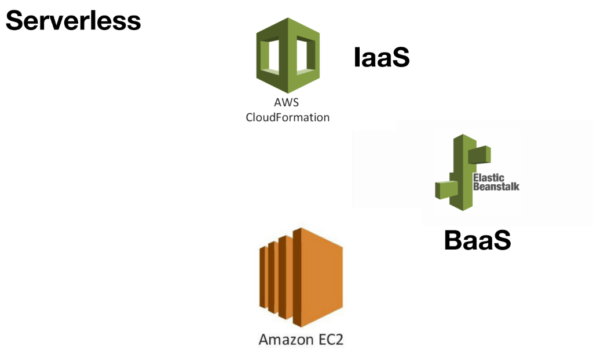

About using that all the component that are already there in the cloud solve a business problem without worrying about the infrastructure the non functional requirement just like scalability , reliability etc

While paying what we use and how  long we use it

**Serverless :**

bringing all the component  that are there in cloud  to solve a business problem while paying what we use and how long we use it.

If we need any customization or if we have to write our own code that is where we use function as nano services that is where lambda come in picture

**Advantages of serverless:**

Low infrastructure cost :  we pay only those services what we use and how long we use it

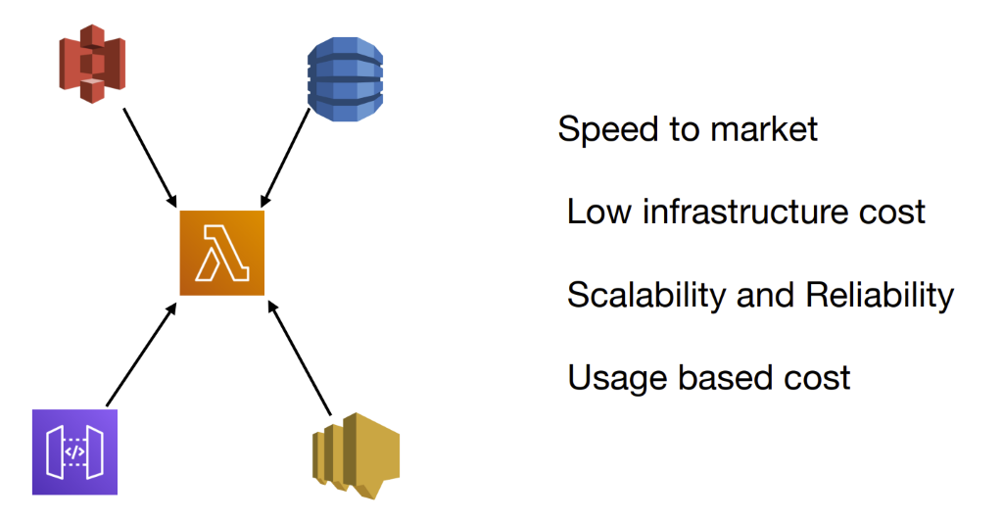

**Usage based cost** :-- if request comes lambda will execute but if no more request lambda will shut

Down entire environment

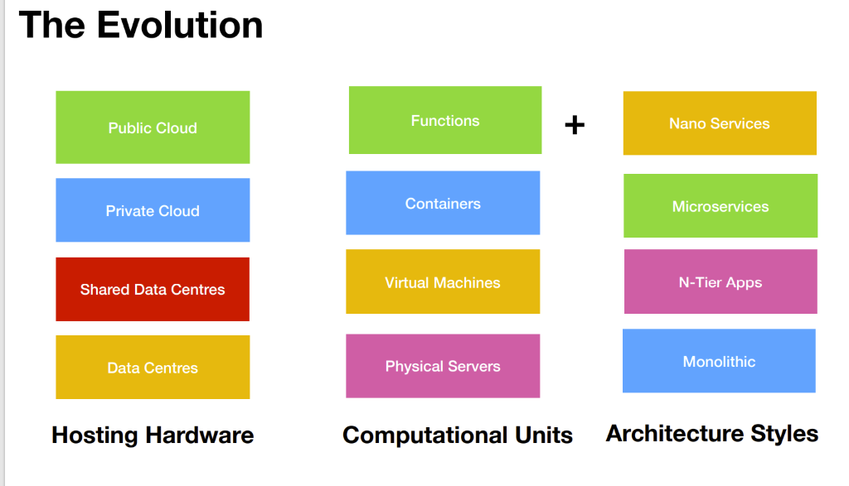

**Note :**

Each function we are creating that is nano services

**Function or nano service** will make up the entire environment

**Nano Services**

Nano services are the next generation of microservices.

Nano services will be triggered by other component or application

Like recommendation we get in netflix if we  are watching any web series that is possible using nano services

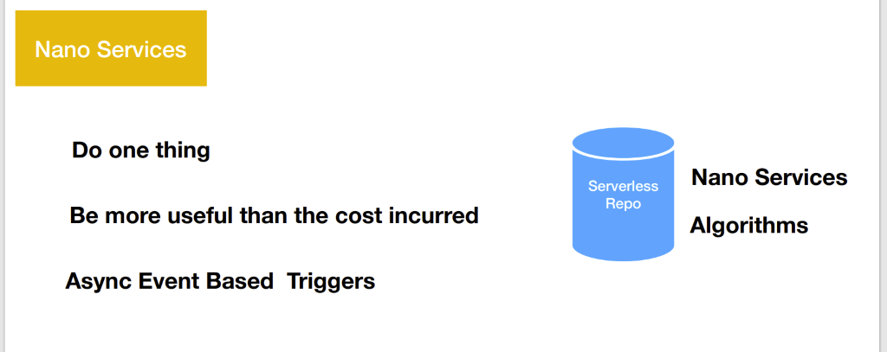

Do one thing with your application

Algorithm is already available in nano service which our application can use

**AWS Lambda**

**What is AWS Lambda used for?**

AWS Lambda is a **serverless compute service** that **runs your code in response to events and automatically manages the underlying compute resources for you**. These events may include changes in state or an update, such as a user placing an item in a shopping cart on an ecommerce website or sns

Serverless platform is comprised of number of services like lambda,s3.

Aws lambda is compute service that allows us to write our own code which will run in response of event

That happen in other resources or other component.

Just like main function in standalone application and the lambda function we create will have a handler function. The handler function can take different input and will return response

We trigger the lambda function through IAM resource policy

We assign IAM role to lambda function to work with other component .

It could be dynamo db, sns

**Lambda function is serverless compute service and when other component trigger lambda function**

**It will execute handler function which we write code**

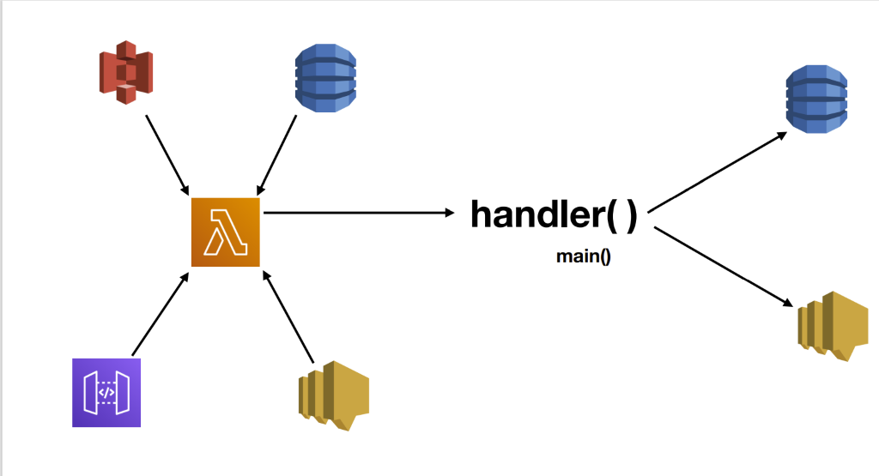

 As a java developer we can create layer in lambda function

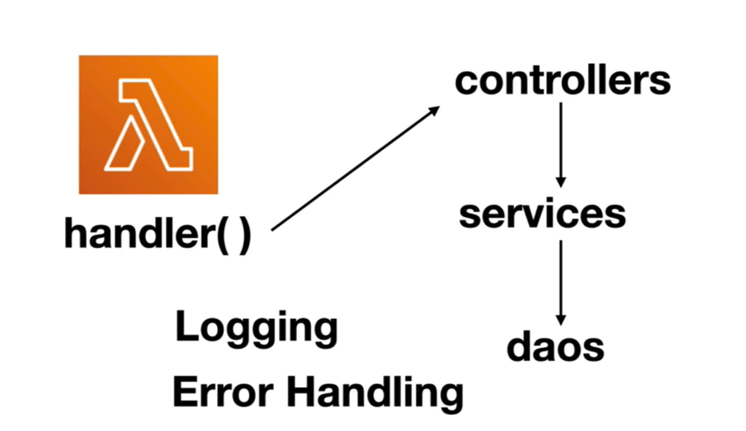

What is AWS Lambda?

[**PDF**](https://docs.aws.amazon.com/pdfs/lambda/latest/dg/lambda-dg.pdf#welcome)[**RSS**](https://docs.aws.amazon.com/lambda/latest/dg/lambda-updates.rss)

Lambda is a compute service that lets you run code without provisioning or managing servers. Lambda runs your code on a high-availability compute infrastructure and performs all of the administration of the compute resources, including server and operating system maintenance, capacity provisioning and automatic scaling, and logging. With Lambda, you can run code for virtually any type of application or backend service. All you need to do is supply your code in one of the [languages that Lambda supports](https://docs.aws.amazon.com/lambda/latest/dg/lambda-runtimes.html).

You can invoke your Lambda functions using the Lambda API, or Lambda can run your functions in response to events from other AWS services. For example, you can use Lambda to:

* Build data-processing triggers for AWS services such as Amazon Simple Storage Service (Amazon S3) and Amazon DynamoDB.
* Process streaming data stored in Amazon Kinesis.
* Create your own backend that operates at AWS scale, performance, and security

**Summarize**

**Aws lambda is compute service . It  allows us to create our own custom code that will be trigger and events happen in other component and in response it will produce a output and in the process of**

**Producing a output and handling a event it can use other component within the eco system**

**And in terms of security both component and lambda should have IAM role**

**Function as a service(Faas)**

Every lambda we create will be a nano services.

AWS lambda also function as a service implementation.

**BaaS :** backend as service

Server will be up even request is not coming that where function as a service **FaaS**come in picture

FaaS : it is event based when other service like s3  fire a event it will trigger lambda and when lambda complete it work it will shut down.

**BaaS deals with backend functionality as a whole, but FaaS addresses microservices in applications only, responding to the events that occur**

**What is Function as a Service (FaaS)**

FaaS or Function as a Service is a platform that lets you run self-contained functions (code snippets) in the cloud.

It offers users to execute already designed codes when triggered. It is popularly being used for its real-time processing of data.

This helps developers in creating or updating codes on the fly that could be executed with any interaction with its element on the page.

The apps and services run on a select type of temporarily running containers (ephemeral containers) in the existing pod. A pod consists of multiple running containers that share the same resources and network.

They exist to provide smooth user integrations and to accomplish a variety of workloads and troubleshooting without disturbing anything else in the process.

So, In FaaS, custom codes run in ephemeral containers. FaaS is meant to manage and regulate microservices in an optimum manner.

Hence, it is an event-based model, to monitor and execute the hosted code bits, without bothering the user with the code execution.

*List of Top FaaS Providers*

* AWS Lambda
* Cloud Functions | Google Cloud
* IBM OpenWhisk
* IronWorker
* Joyent Manta Functions
* Microsoft Azure functions
* PubNub BLOCKS
* Serverless Docker

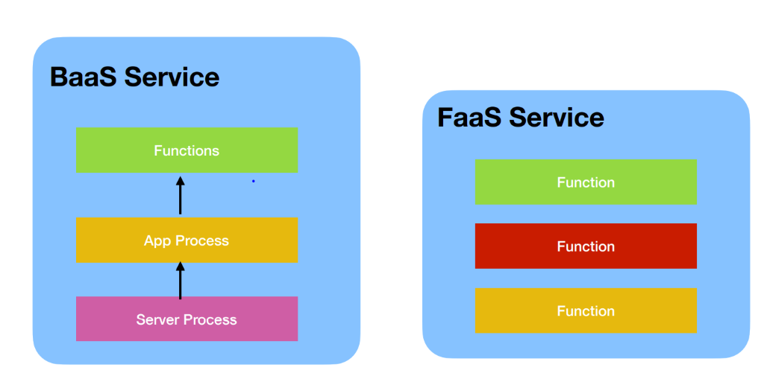

In case of FaaS we will charged only how how much time function took to execute not for how much time environment take to come up

We don’t need to take care of scaling , security etc. These are the advantages  of FaaS

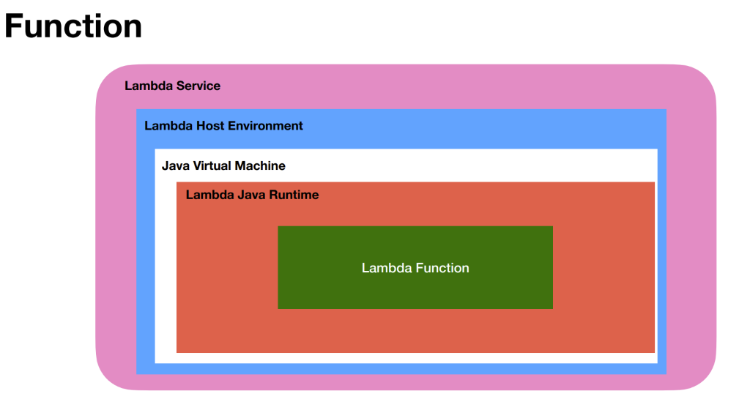

**UseCases**

**Microservices :** is event driven

**Use case 1**

Our application can deploy in EC2 , elastic beanstalk and static application in s3 and these application can make call in api gateway component in aws which will trigger lambda which is responsible for communicating with database like dynamodb

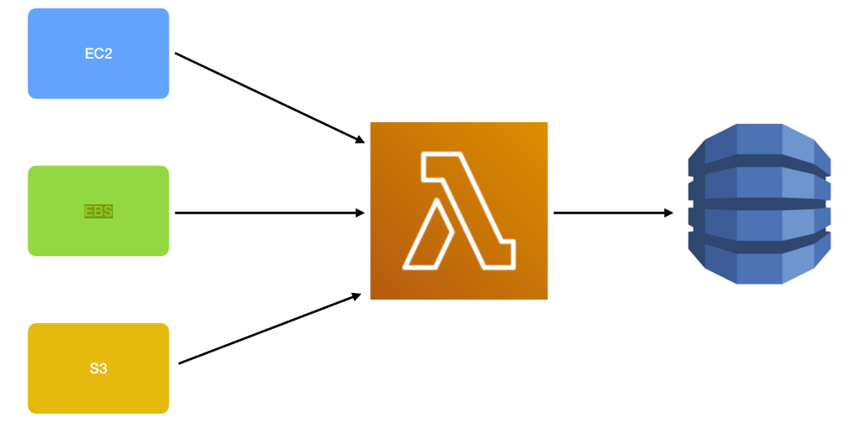

**Use case 2**

**Data processing :** data can come from dynamo db or kinesis stream and lambda can scale itself

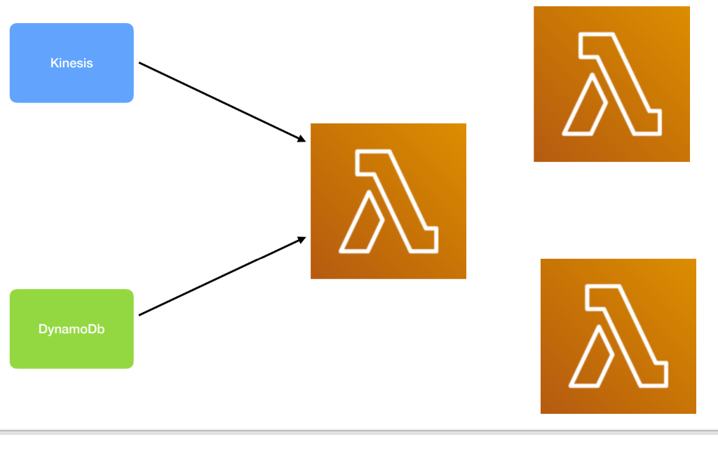

Use case 3:

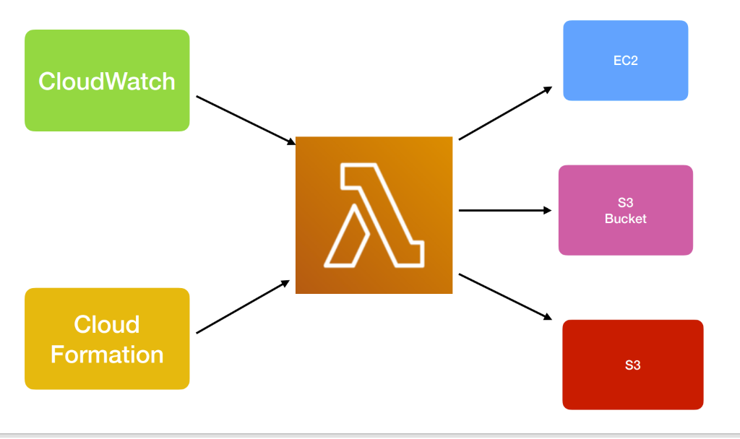

If any instance is deleted lambda function can do clean up

=====================================================

**Aws lambda notes**

Introduction To AWS Lambda

Last Updated : 26 Jun, 2022

Read

Discuss

Practice

Video

Courses

**AWS Lambda** is the new computing system that offers a variety of benefits like **real-time data processing and custom back-end service.** With so much information available about AWS Lambda, it can be hard to know what it is without an introduction.

AWS Lambda

Here’s a breakdown of the introduction in the form of frequently asked questions about this system, to help a person determine if it’s the right option or not.

1. **What is AWS Lambda?** AWS Lambda is an Amazon[serverless computing system](https://medium.com/@pmuens/aws-fundamentals-what-is-lambda-32d17a89dda2)that runs code and automatically manages the underlying computing resources. It is an event-driven compute service. It lets a person automatically run code in response to many types of events, such as HTTP requests from the Amazon API gateway, table updates in Amazon DynamoDB, and state transitions. It also enables the person to extend to other AWS services with custom logic and even creates its own back-end services. For example, just write the code and then upload it as a .zip file or any container image. The service works by running code on high-availability computer infrastructure. It then performs all the administrative duties of that compute resource such as:
   * providing maintenance on the server and operating system,
   * automatically scaling and managing the person’s capacity provisions,
   * handling security patch deployment
   * lambda extensions
   * code monitoring
   * logging
   * concurrency
   * function blueprints
2. **How Does AWS Lambda Work?** While AWS Lambda may seem confusing at first, it really isn’t. In fact, it’s actually just a simple process:
   * Start off by uploading the code to AWS Lambda.
   * From there, set up the code to trigger from other AWS services, HTTP endpoints, or mobile apps. AWS Lambda will only run the code when it’s triggered and will also only use the computing resources needed to run it. The user has to pay only for the compute time used.
3. **What are the Advantages of AWS Lambda?** AWS Lambda offers a variety of benefits to its users. Here are 3 of the biggest benefits one should know about when deciding if AWS Lambda is the right choice:
   * **It doesn’t require the user to manage any servers.** Since AWS Lambda automatically runs the user’s code, there’s no need for the user to manage the server. Simply write the code and upload it to Lambda.
   * **It empowers the user to easily scale.** AWS Lambda runs code in response to each trigger, so the user’s application is automatically scaled. The code also runs in parallel processes, each triggered individually, so scaling is done precisely with the size of the workload.
   * **It’s affordable.** With AWS Lambda, one doesn’t pay anything when the code isn’t running. The user has to only be charged for every 100ms of code execution and the number of times his code is actually triggered.
4. **What Can You Build with AWS Lambda?** AWS Lambda can build a variety of things. Here’s a quick list of just a few use cases for it:

* Data processing
* Real-time file processing
* Data validation
* Filtering
* Sorting
* Real-time stream processing
* 3rd-party API requests

Own Backend **How Much Does AWS Lambda Cost?** As previously mentioned, with AWS Lambda user only pays for what he uses, factoring in the number of requests and duration of the execution of the code. No charges are taken for creating lambda functions. Lambda considers a request to be each time it starts executing in response to a trigger such as an event notification or an [invocation volume](https://dashbird.io/features/aws-lambda-serverless-monitoring/). The duration of the code is calculated from the moment the code begins executing until it returns or is terminated. If one is unsure about whether AWS Lambda is the right choice or not, there is a **free tier option available to try**. This option includes 1M free requests per month and 400,000 GB-seconds of compute time per month.

================================================================

**Create the first lambda**

**While**creating lambda function select node js since we are to edit out code

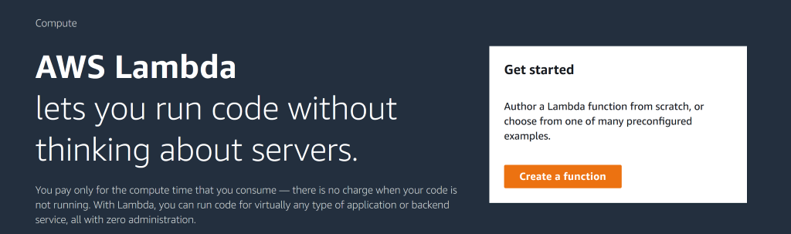

VPC : virtual private cloud where we want lambda function to be run

**Typically lambda function will be invoked by add trigger(** this can be s3 or any other resources)

**Note :**

For every lambda function invocation there will be a unique request id generated

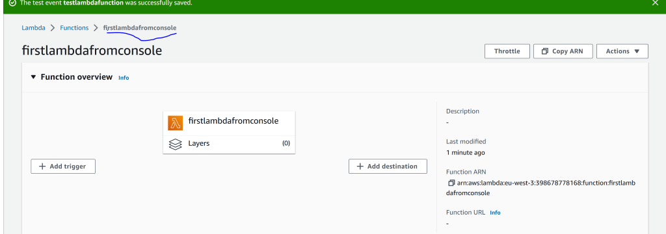

Create test to test lambda function

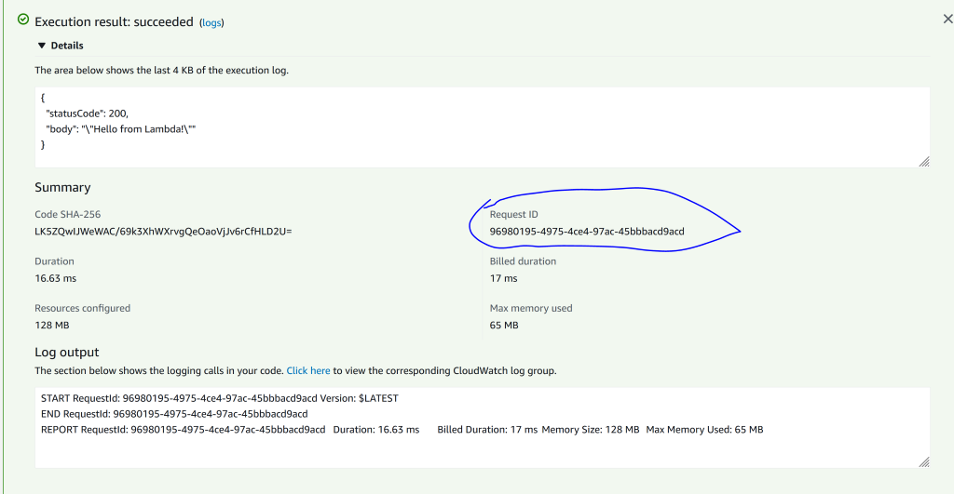

**Note :**

These function logs are cloudwatch logs.  start request id and end request id will create and both are same

Billed duration is 17 ms

Note :

We are deploying using aws console but later will deploy function using sam cli

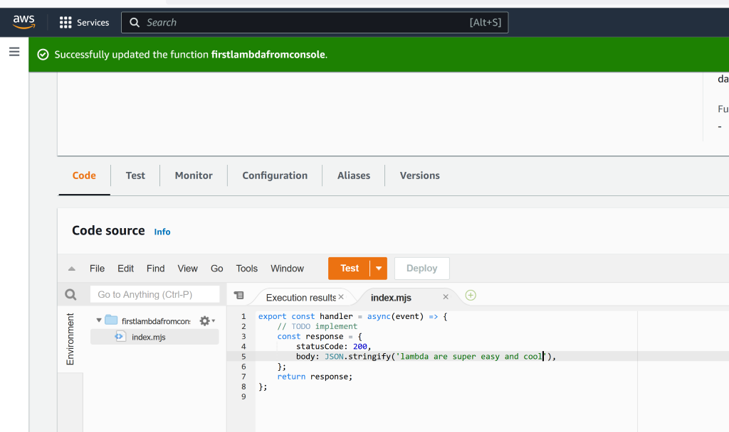

**The Lambda workflow**

**When**we create or deploy lambda from aws cli the lambda code will be store in aws lambda repository in aws cloud.  when the lambda function get trigger the lambda service first create

Virtual machine on cloud which involves a linux operating system . On top of this virtual machine it will add a language runtime if it is java based it will add JVM which can use to create a  lambda java runtime then it will pull java .class file from repository load it into memory and create a instance of that class file and within the instance it will invoke a lambda function.

Note : lambda service is responsible for creating entire environment

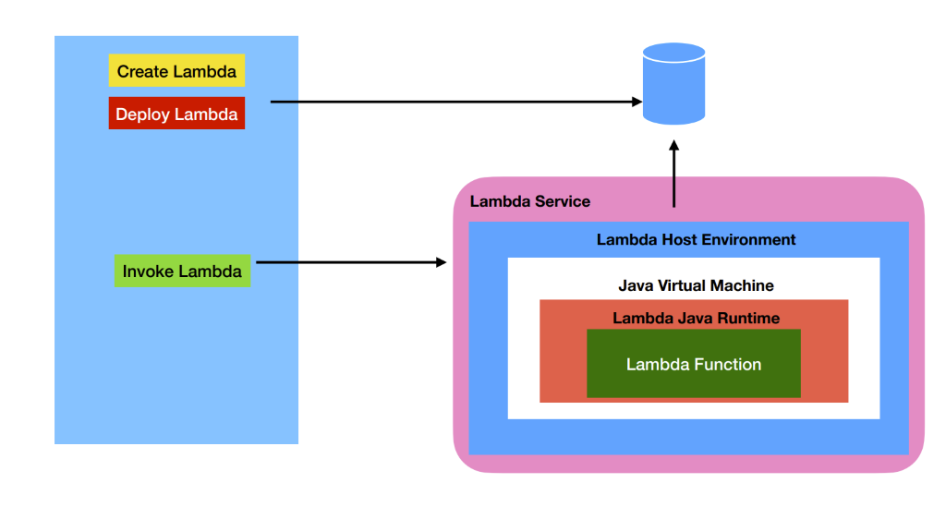

Lambda function can be invoked from console which is just for testing  and it can be invoked form aws cli .

In most cases lambda function is triggered by other services in aws like s3, dynamo db and api gateway , sns messaging and  so on.

* When user hit ths url in api gateway it will trigger a lambda function.
* Similarly upload some file in s3 that will raise a event and trigger a lambda function.
* If we put a message in sns topic that will trigger a lambda function.

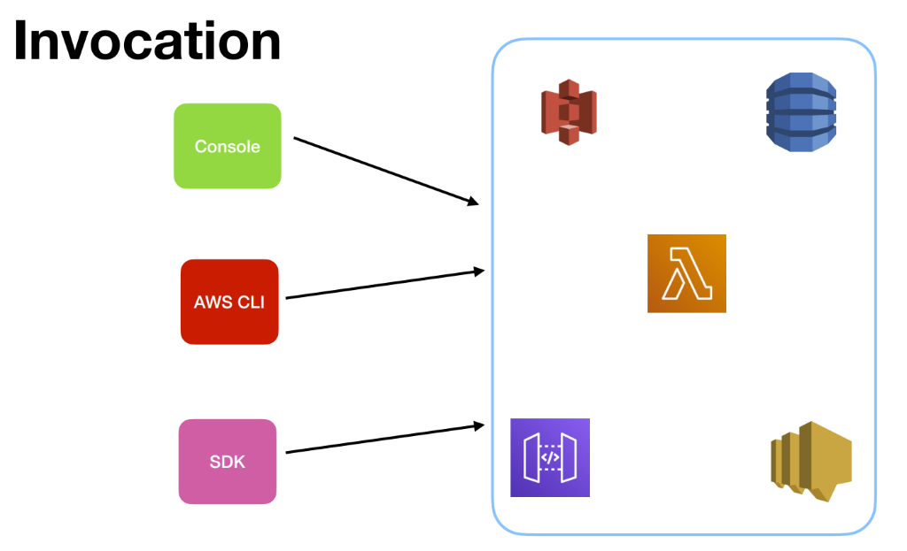

**Invocation type and modes**

**First way :**

When we create lambda function  in aws we trigger it using test in aws

**Second way**

Aws cli  we will run aws command which will trigger aws lambda function.

**Third way**

We can programmatically trigger lambda function within our application using SDK

**Fourth way**

Lambda can be triggered by event happening in other resources in aws

**Note**

There are different modes in which we can invoke a lambda function

**1- Synchronous mode**

Where a lambda function is expected to r**eturn a response** right away

**Ex :-**

**API gateway, Alexa, Cloud front**

For a web application or other content that's served by an Application Load Balancer in Elastic Load Balancing, **CloudFront can cache objects and serve them directly to users (viewers), reducing the load on your Application Load Balancer**.

**2- Asynchronous Mode**

Lambda function won't return any response. The return type of lambda function is void

Ex :-

S3, sns, cloud formation

Resource creation  or deletion in aws using cloudformation  can trigger a lambda function

**Third way :-**

**This** is where lambda function will not triggered instead  lambda service will  do polled to other sources like kinesis data stream , dynamo db stream  or SQS

**A**piece of code that is executed when event triggered is  lambda function.

Lambda function scales automatically.

Onces the lambda function is done it will tear down entire infra structure

**Lambda function have some limit**

**Note :**

 lambda function can take environment variable and the space taken by those is 4 kb

Lambda function received parameter ------64 mb for sync

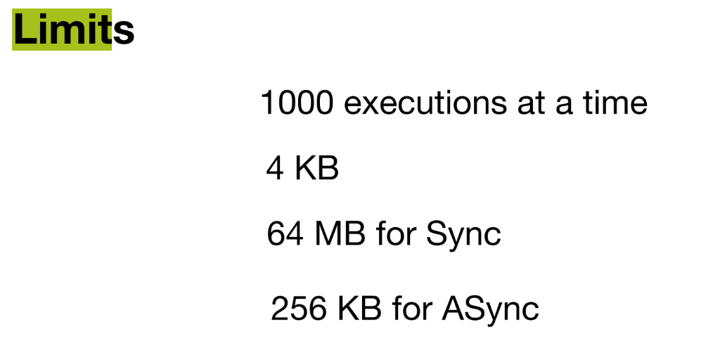

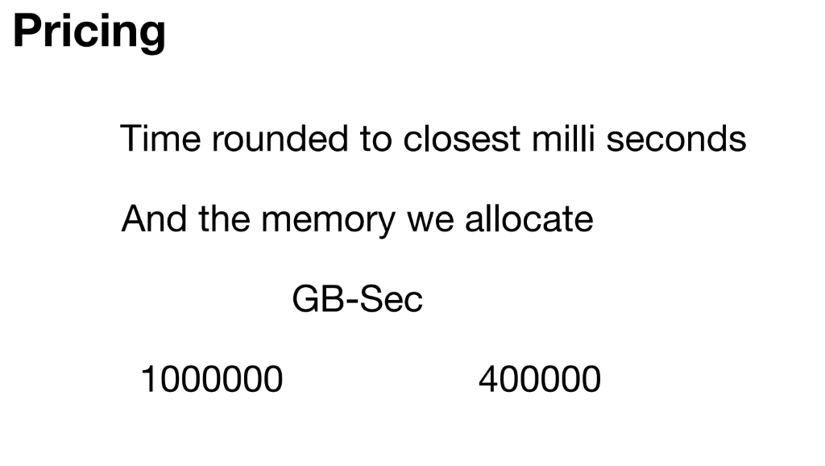

  Section 2 : Tools of Trade

**AWS SAM**

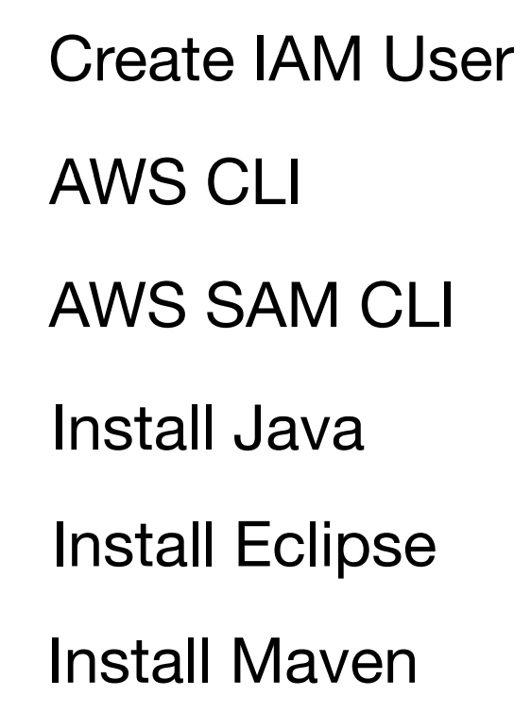

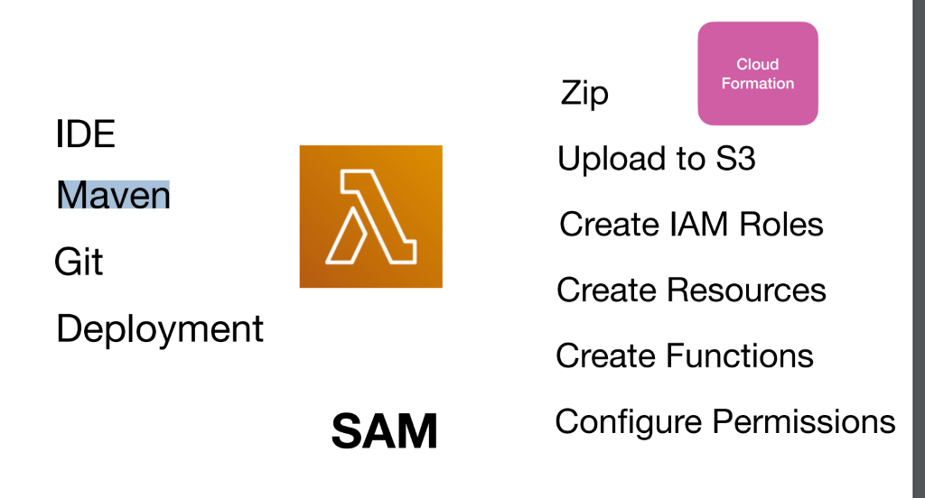

To automate this we can use cloud formation but we need to write lot of configuration that is where SAM serverless application model come in picture.

Sam  take care of all those step which we see on right handside.

**Note :**

Configuration file of SAM is very simple compared to cloud formation template

Will configure resources that will trigger lambda function and  also configure resources that require for this lambda function to work

**What is difference between Sam and CloudFormation?**

**SAM makes Serverless/Lambda deployments easier**. Even CloudFormation can deploy lambda scripts using inline scripts but it has a limitation of 4096 characters and you cannot pack custom dependencies, python libraries. So to make Lambda/Serverless deployments easy SAM is used. SAM is a CLI tool

**NOTE**

SAM is the extension of cloud formation or superset of cloud formation

**Should I use Terraform or CloudFormation?**

**If you are looking to provision services on multiple cloud platforms, Terraform is your go-to option**. While Terraform supports all cloud vendors like AWS, GCP, Azure, and many others, CloudFormation is confined only to AWS. So, in case your environment involves multiple cloud deployments, Cloudformation is not for you.

NOTE :

Using sam not only lambda all the resources can be created

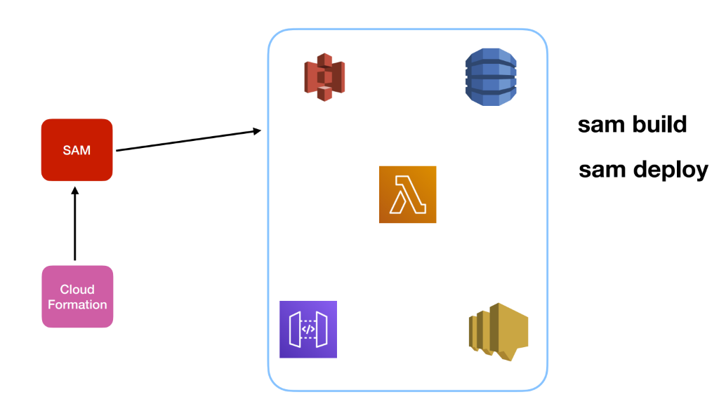

**Create IAM User**

**IAM :-** Identity and Access management

**Step 1 :- Aws cli install :**

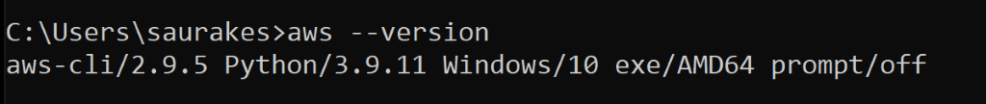

**Step 2 :- AWS SAM CLI** :

---- it uses internally AWS CLI to get the work done

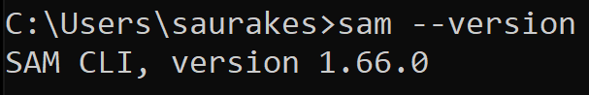

Later on will use sam build and sam deploy within   aws lambda project

**Yaml syntax**

Yaml is become standard in dev ops world for configuration file

Yaml :-

 stand for A'int markup language

Superset of json

Strictly follows indentation

**Yaml give**

**Simple types :- like** int , char ,null

Lists

Object

Dictionary or map

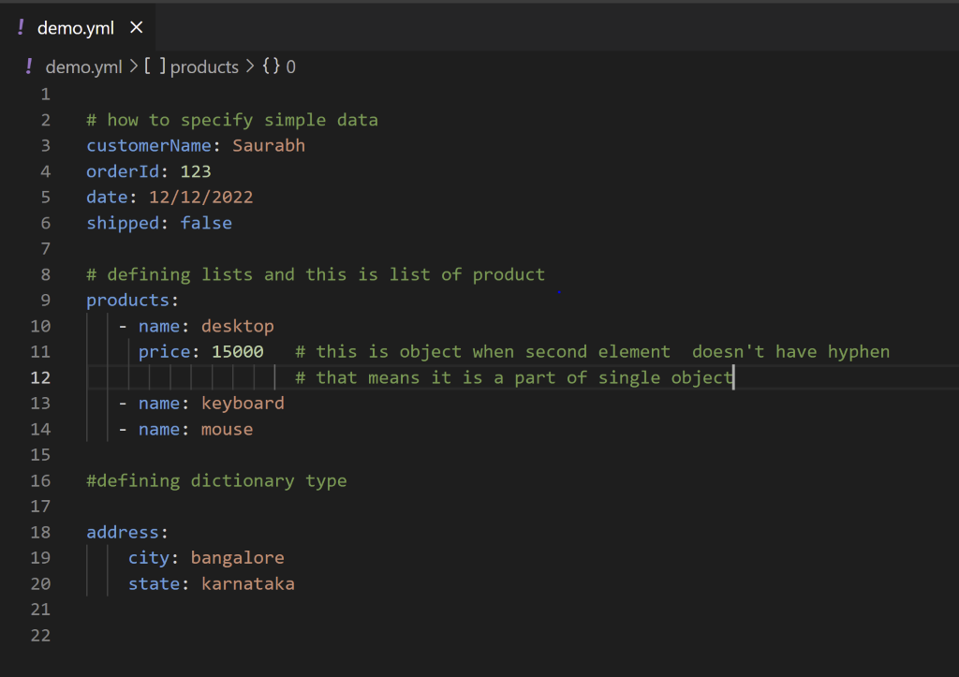

**What is AWS Lambda?**

AWS Lambda is a compute service that lets you run code without provisioning or managing servers. Lambda runs your code on a high-availability compute infrastructure and performs all of the administration of the compute resources, including server and operating system maintenance, capacity provisioning and automatic scaling, and logging. With Lambda, you can run code for virtually any type of application or backend service. All you need to do is supply your code in one of the [languages that Lambda supports](https://docs.aws.amazon.com/lambda/latest/dg/lambda-runtimes.html).

You organize your code into [Lambda functions](https://docs.aws.amazon.com/lambda/latest/dg/gettingstarted-concepts.html#gettingstarted-concepts-function). **Lambda runs your function only when needed and scales automatically, from a few requests per day to thousands per second. You pay only for the compute time that you consume—there is no charge when your code is not running.**

Section 3 : Create a serverless Project

**Introduction**

Objective

Create and deploy lambda project in aws using sam cli

For this first we will create project using sam init  command line which will generate structure

We will understand the structure which has maven project into it . We will import the project into

Sts

**Step**

Create a project

Create lambda within the project

Understand template.yaml structure

Understand pom.xml

Sam build

Sam deploy

**Requirement**: create serverless project using sam cli

**Create a sam project**

When we will  hit restful end point it will invoke our lambda

Template.yaml will create all that is required to work

**Sam init**

Project name firstlambda

**When**we run sam build it will look template.yaml and within the file it will look how to run lambda function

Three command we need to run :

Sam init

Sam build : it will create build and lib folder

Sam deploy : it will deploy in aws as cloudformation template

Sam –help

Note : we can validate template.yaml using**sam validate**

**Note :**

**Testing lambda local**

**Very**first time it will download the docker image and simulate with aws

**Sam local invoke HelloWorldFunction –event events/event.json**

**Access logs**

We can access logs of aws lambda in local using sam command

**sam logs -n HelloWorldFunction --stack-name firstlamdba –tail**

**Security**

Will attached security policy to IAM role

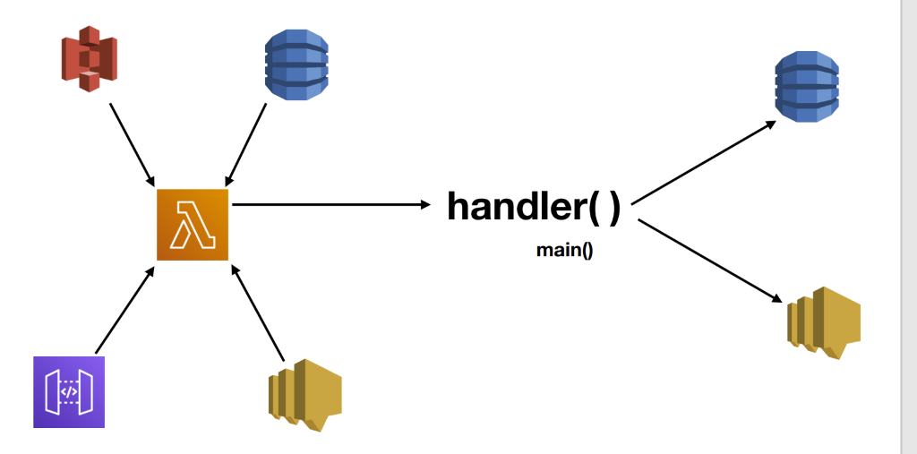

When external source like dynamo db and sqs want to trigger lambda , it will check whether they have proper permission to trigger lambda that will be decide using **IAM resource policy**

And then once lambda will trigger then it can interact to other component and that will be decide by IAM role where security policy will attached

This is policy of IAM role for lambda function.

When we create project using sam  that time will give for IAM role and later will attach policy.

This we can see in permission section f lambda function created

By default **resource based policy** is empty since lambda function is not triggered by any other component

When we configure other component like api gateway , s3 that is where **resource based policy** come into picture

Resource based policy we can configure using template.yaml to need to come in aws account.

**Execution role or iam role :** which specify what lambda can or what permission it has

**IAM Resource Policy:**which determine which component can trigger lambda

Cleanup

**aws cloudformation delete-stack --stack-name firstlambda**

Section 4: Parameter and return types

Every lambda function will create a context object where we can get all lambda environment.

We can get aws request id, how much time is left to execute lambda

**Step:**

Create class

Change in template.yaml ( configure class name with package and function name)

Sam build

We can test it in aws or locally

To invoke it locally we need to change**event.json (pass value as argument)**

sam local invoke HelloWorldFunction --event events/event.json

**Question : how to pass a list and how to get back list from lambda function**

Typically we create one lambda function inside a class but for demo purpose we are creating in same class

**Return List from**lambda function

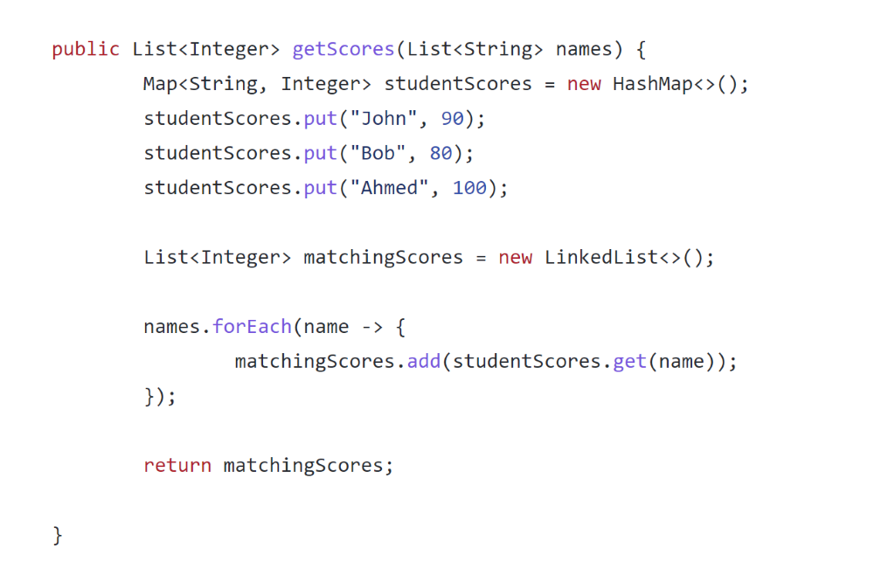

Change in template.yaml

Pass array in event.json

Sam build

sam local invoke HelloWorldFunction --event events/event.json

**Maps**

Pass map as input and return type void

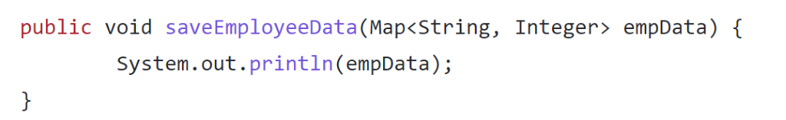

Will get response as null

**Maps of list**

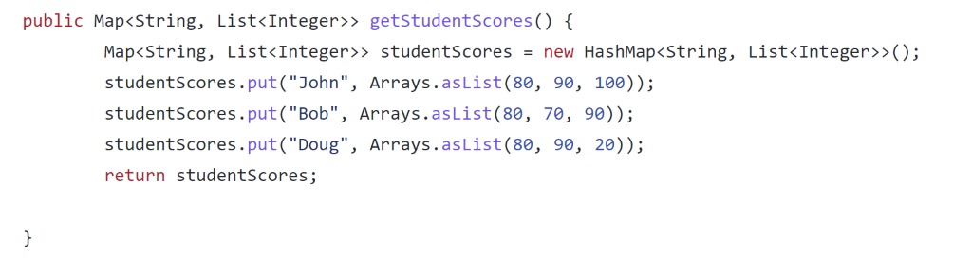

It not getting any input just returning output.

We don’t need to pass event.json

Just run :-

Sam build

sam local invoke

It will came to know function by looking template.yaml file

**How to pass java object as parameter to lambda function and also how to return java object**

Create pojo class

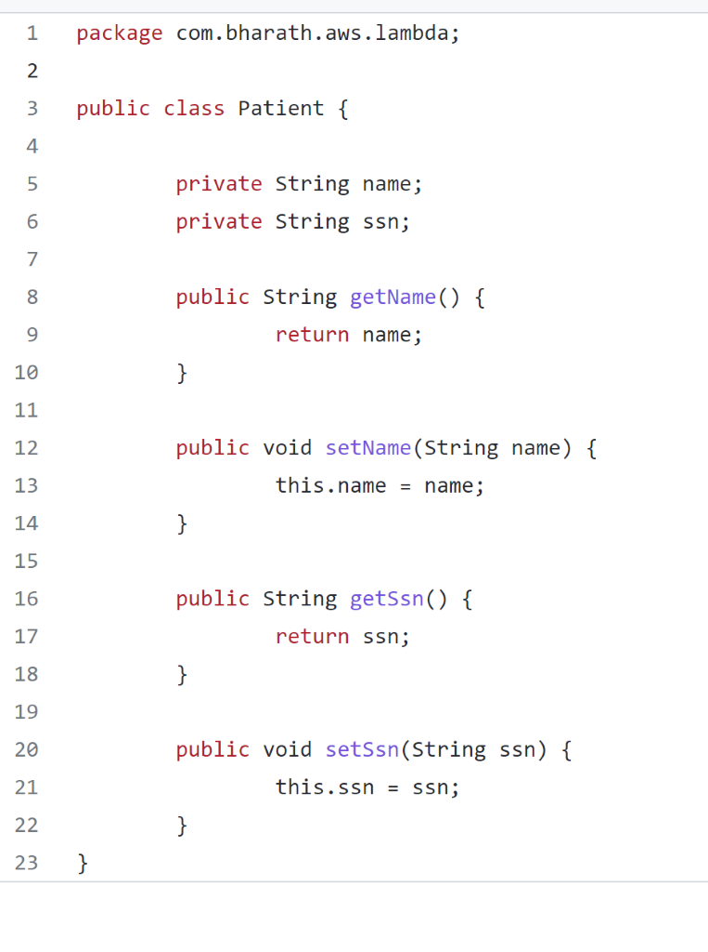

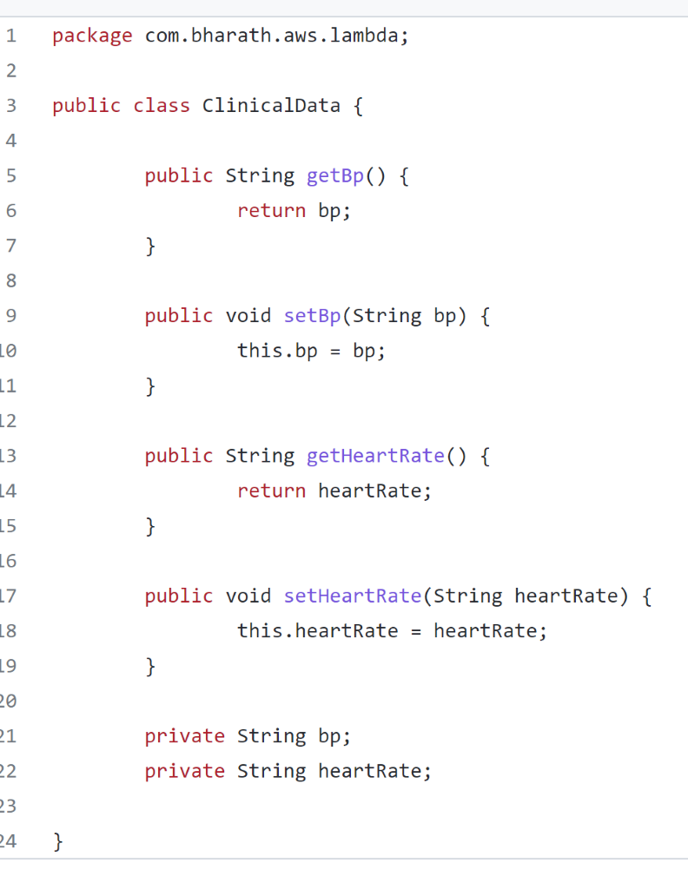

Now in lambda function will use patient as input and return clinicalData as output

**Input and Output stream**

**How a**lambda function dynamically receive input and output types

Using **InputStream**and **OutputStream**we can get any type of data and send back any type of data

**Input**: may be in uppercase or lowercase

**Output**: lowercase

**Context Object**

**When** we run lambda function. Every lambda function get request id in **console**and version

As we keep deploying lambda function there will be specific version.

Duration it  took to execute lambda function and memory it taken.

All these info will be available in a object called context.

Note :

This context object is a part of java core lib which is present in pom.xml

We can use context object as a additional parameter in any of the lambda function

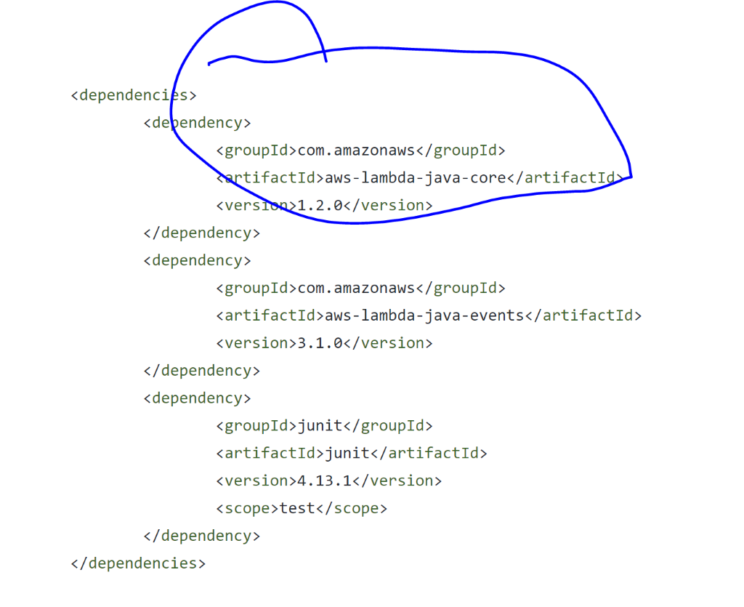

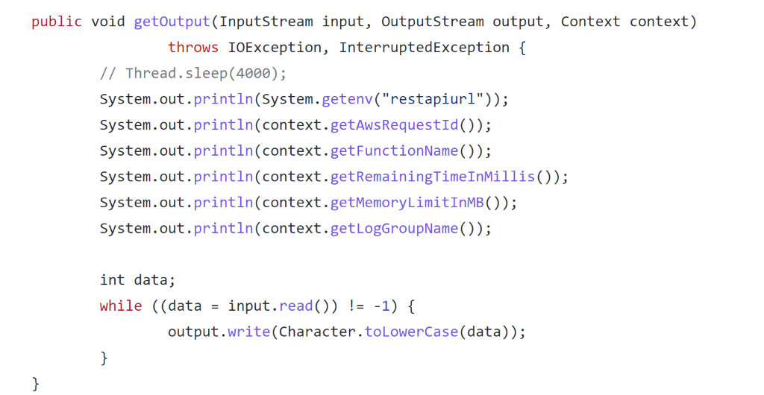

**Configure timeout**

**Every**lambda function has to finish within a certain amount of time otherwise will see a timeout error

The default value for lambda function to finish is**3 second**

**Note :**

We can change the value of timeout in template.yaml

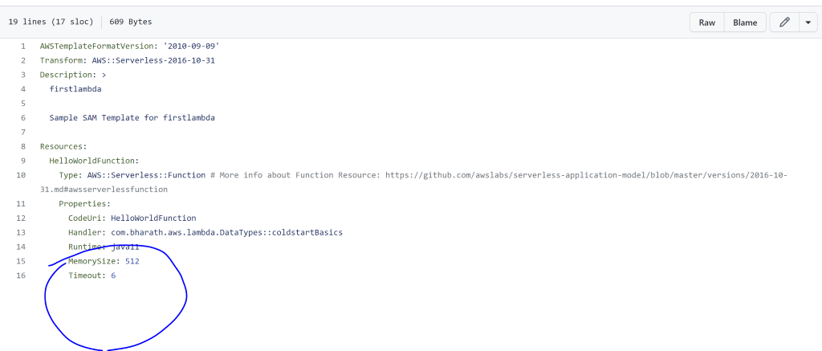

Maximum timeout for lambda function : **15 minutes**

**Set and read Environment variables**

**Learn :** how to pass environment variable from template to lambda function dynamically.

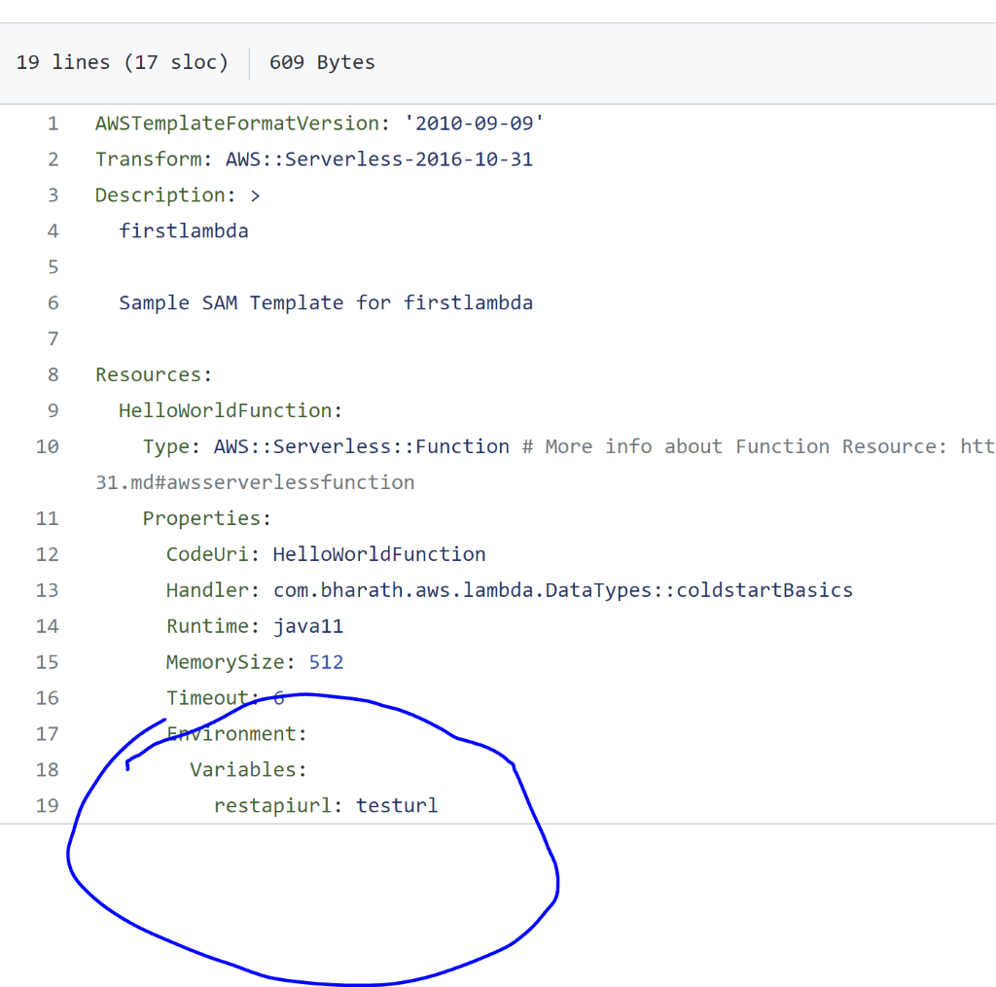

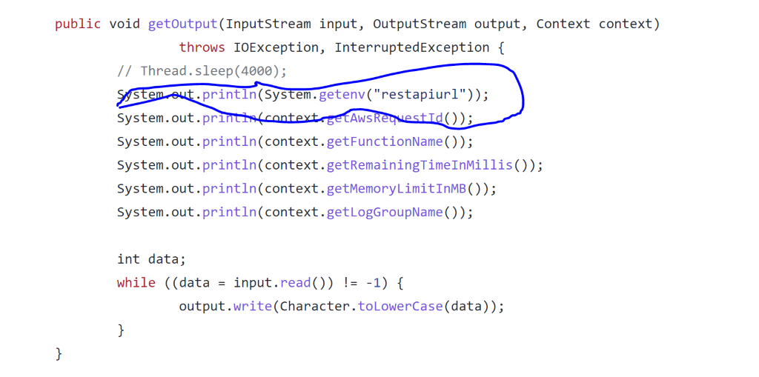

So this property restapiurl is dynamcally coming from template.yaml to lambda function

**Variables in lambda**

**Learn :**how lambda service instantiate our lambda function

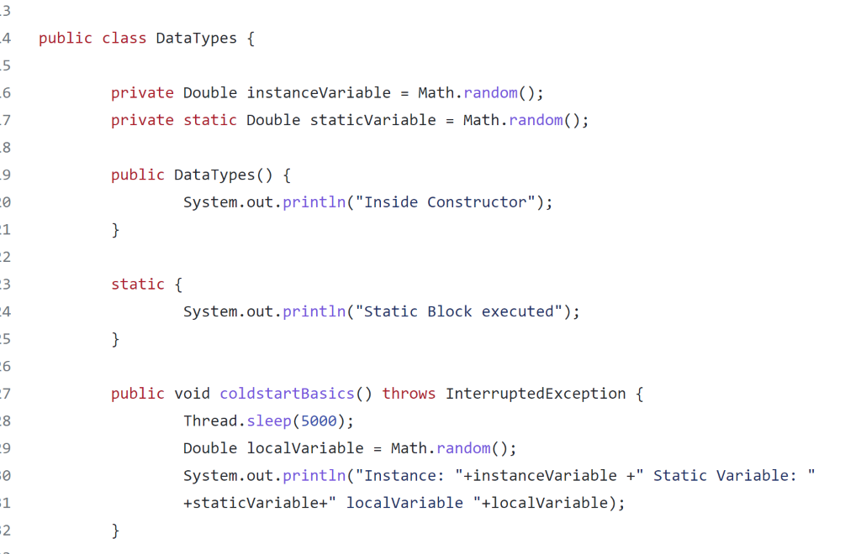

**Cold start basics**

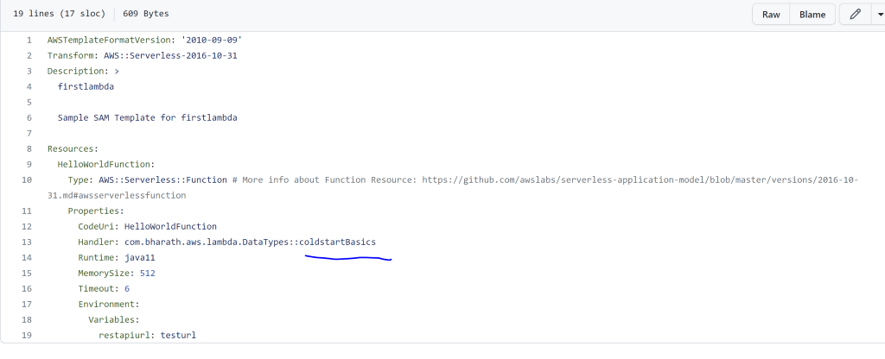

**We will**see how same lambda instance will be use for multiple invocation

**When Does Cold Start Happen?**

The very first cold start happens when the first request comes in after deployment.

After that request is processed, the instance stays alive to be reused for subsequent requests. There is no predefined threshold after the instance gets recycled, the empiric data show some variance of the idle period.

Instance will not create again and again when we will trigger lambda

Whenever lambda is created first time the entire context will get created.

Lambda will be instantiate only once any if any expensive operation is there then

Will define as globally and will use inside function

**Invoke remotely from command line**

**Learn :** how to invoke remote function from command line

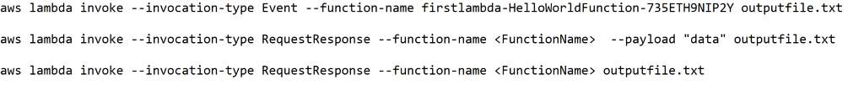

Section 5: create serverless API

**Synchronous usecase**

**Objective :**how to create serverless api using lambda function

Will use api gateway to trigger lambda function

**The end user should be able to create order in database and also retrieve order from database**

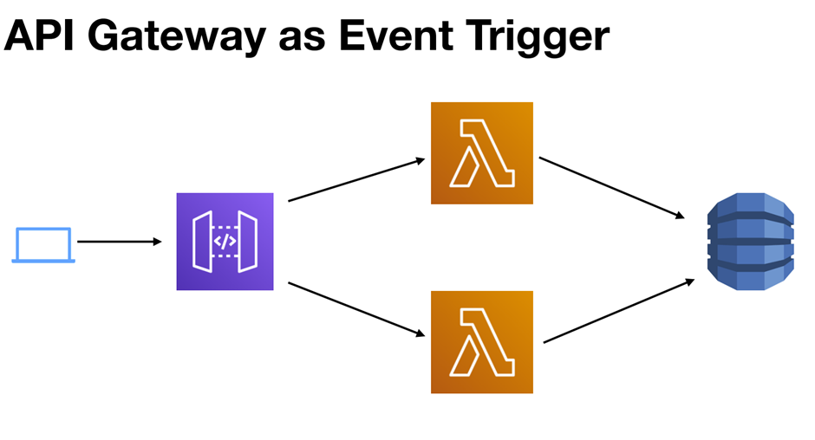

**Will use** api gateway as front end this guy will expose to end point based on http

When the end user hit the endpoint it will trigger respective lambda which will create order in database or retrieve all the order from th d/b

Dynamo db will be our no sql or unstructured d/b.

**Lambda will read order from api and will responsible to save order into database**

**API Gateway Quick Review**

**API gateway**component is a serverless component that can be use to create api to our backend functionality. It will act as layer of abstraction between client application and backend.

The  advantage of this we can implement security at this layer and our application need not to be worry.

Ex :

 api gateway can be easily used with aws cognito which is security component

Similarly we can aws cloudfront in front of api gateway

Api gateway can handle 1 to 10000 request per second

**Api gateway will trigger lambda and this api will be use by client in serverless environment**

Note :

We don’t have to write any code for api gateway. It is a simple configuration

**Dynamo DB Quick review**

**Dynamo db :** it is serverless unstructured component using which we create table , indexes.

It has scaling and availability zone across multiple region

Dynamo db have table which is having item( **item**is like row and **attribute**is like column).

Every table is like mandatory**partition key**( like primary key in table)

And also it will have sort key which will help when we query the data

Dynamo db will use to store data of our lambda function

**Note**:

we can  trigger a lambda function from dynamo db stream

And the data of table can be use by lambda function to process the business logic

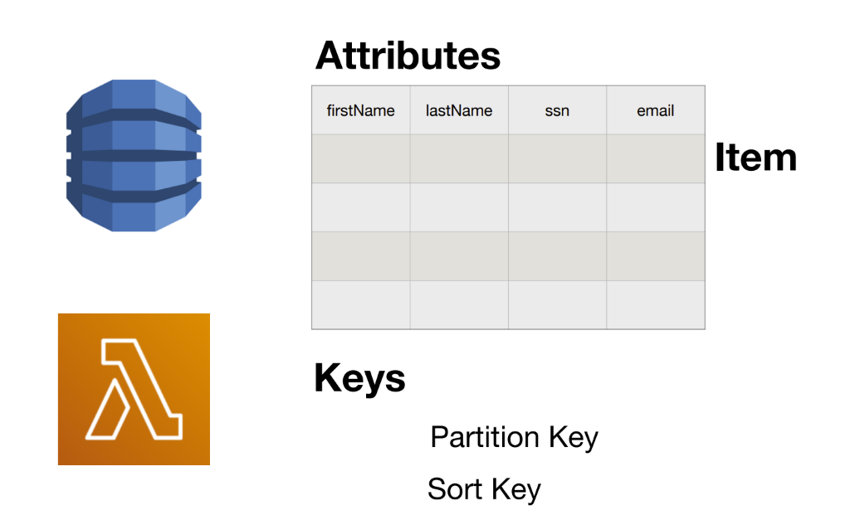

**APIs and SDKs**



**Here** event source is API Gateway

We need to include aws-java-sdk-dynamodb in pom which will help lambda function to communicate with other service like dynamodb , sns ,s3 etc

**Note :**

**Every** component in aws has it own sdk

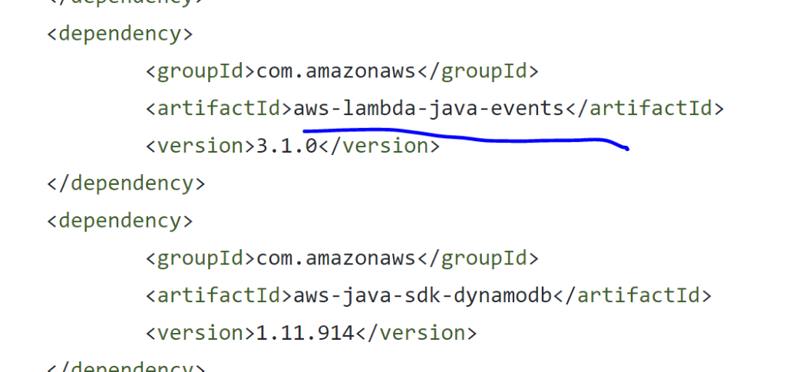

**aws-lambda-java-events will  contain all the pojos when events are fired**  and that will store as object and ass to lambda function

We also need to add jackson lib

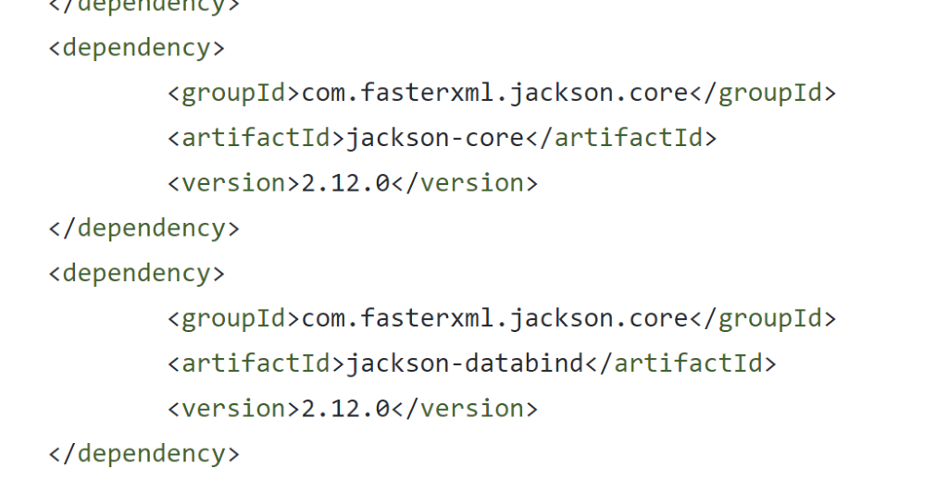

**Security**



**Here** two lambda function . One will create order in d/b and one will read it from d/b.

These two lambda function should have appropriate permission to do operation against the dynamo db. These lambda function will have execution policy

On the other hand api gateway will have resource policy which will trigger lambda function

**Execution role or iam role :** which specify what lambda can or what permission it has

**IAM Resource Policy:**

which determine which component can trigger lambda

It will give permission to component to trigger lambda

Note :

Resource policy will automatically created  thanks to sam. We just need to configure api gateway in template.

For execution policy we need to configure in template

**SAM Template**

Usecase :

Two lambda function

One to create order in d/b

Second to read info from d/b

Then we have api gateway which will host two endpoints

First endpoint is to post data

Second endpoint is to read data

APIGateway will automatically trigger lambda function.

All the common properties of various lambda can be defined in global block of template.yaml

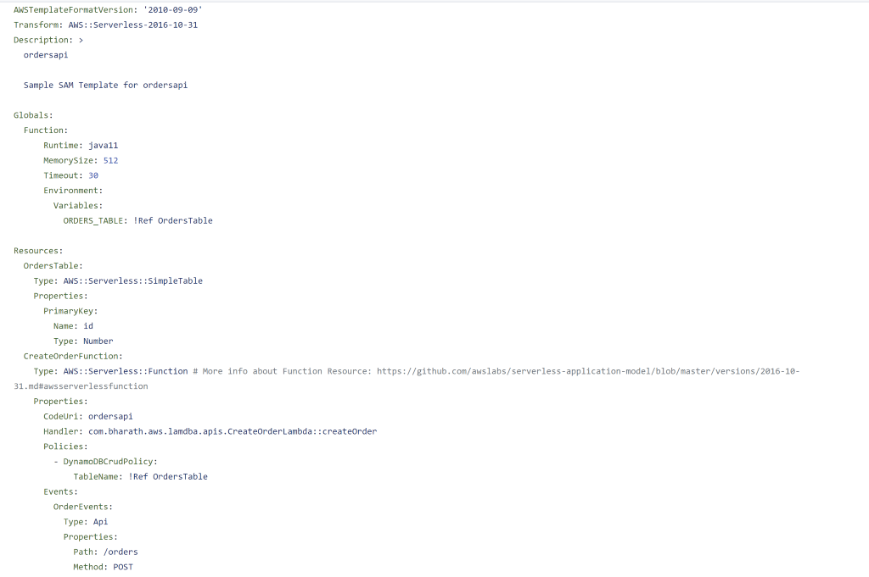

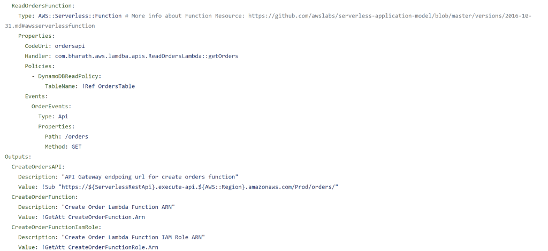

**Cloud formation Intrinsic Functions**

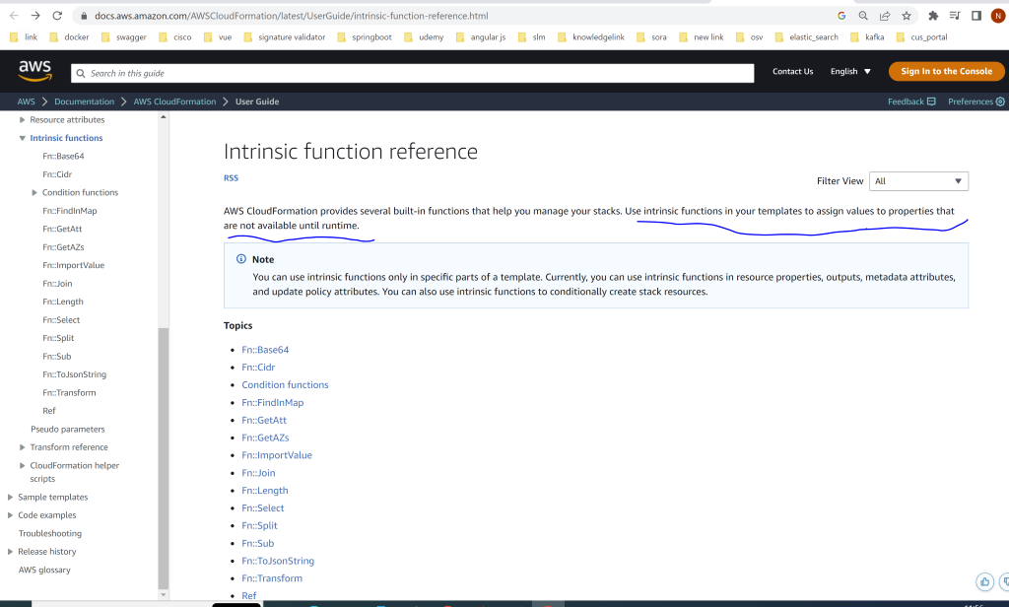

**Create Project**

**Sam init**

**Select option 1: aws start template**

**Select 8 :- java 8**

**Select 1- maven**

**Projectname :- ordersapi**

**Select option 1 : Hello world example**

 Now project will create

**Create Order Lambda**

**1-Create dto :** Order class

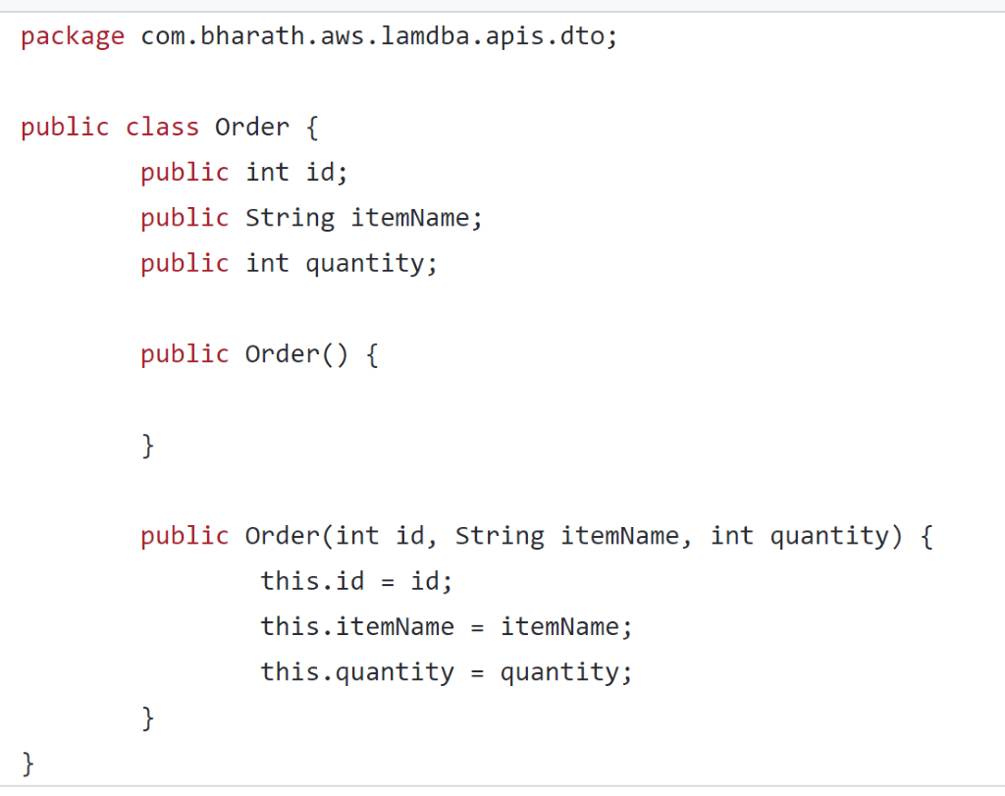

Always define a default constructor if we define a parametrized constructor

**What is ObjectMapper used for?**

ObjectMapper provides functionality for reading and writing JSON, either to and from basic POJOs (Plain Old Java Objects), or to and from a general-purpose JSON Tree Model ( JsonNode ), as well as related functionality for performing conversions.

**2-Create class :---** CreateOrderLambda

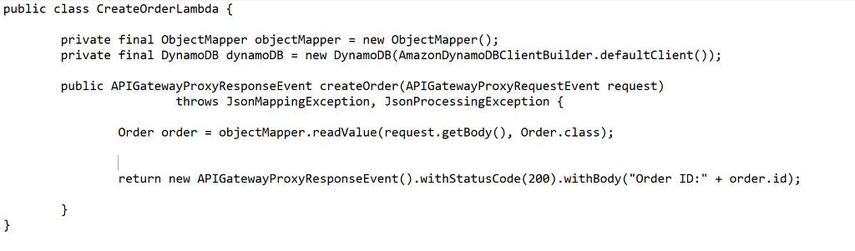

**Note :**

Till now we have created Order class and CreateOrderLambda function

**Bind API Gateway to trigger Lambda**

**CodeUri : orderapi (** since template file is present under this folder)

**Events**: key will bind API gateway to lambda function automatically

All this happen when we deploy . It will create a api gateway and lambda function and also it will bind it.

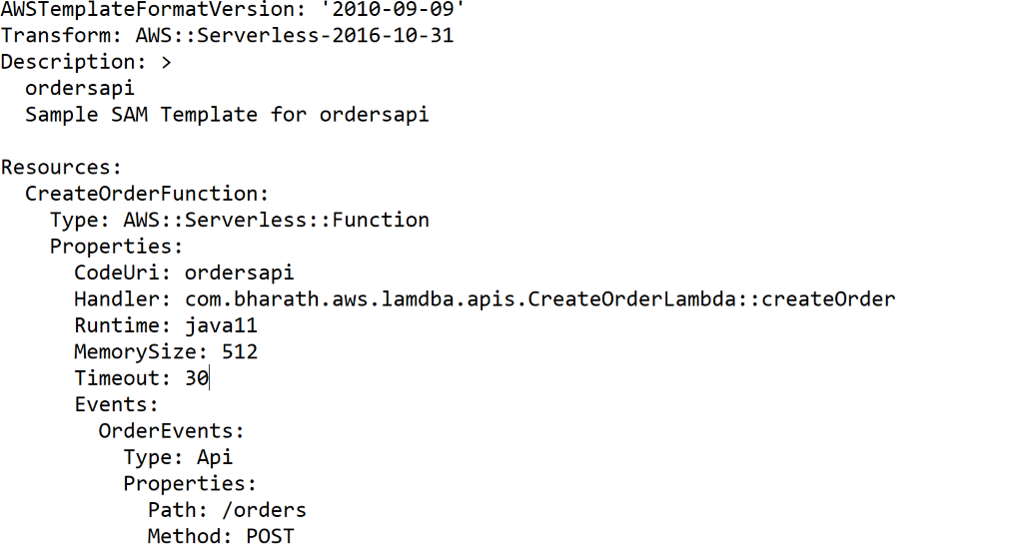

**Deploy and Test**

**Sam build**

It will copy the artifact and the template.yaml to the build directory

**Sam deploy –guided** first time

Stack name : ordersapi

Region

It will  push our code and config as a zip to s3 bucket and then from there it will use cloud formation and it will create all the resources

**Go to cloudformation-resources in aws**

It will  create all we can check logs here

To test this : go to api gateway

**Orderapi**: api gateway name

Go to ordersapi

Click on stage in left hand side copy the url and paste it in postman

**Url copied/ orders**

**{**

**Id:123,**

ItemName: macbook,

Quantity:100

}

Post it and api gateway send it back response.

**OrderId = 123**

**Create and configure read orders lambda**

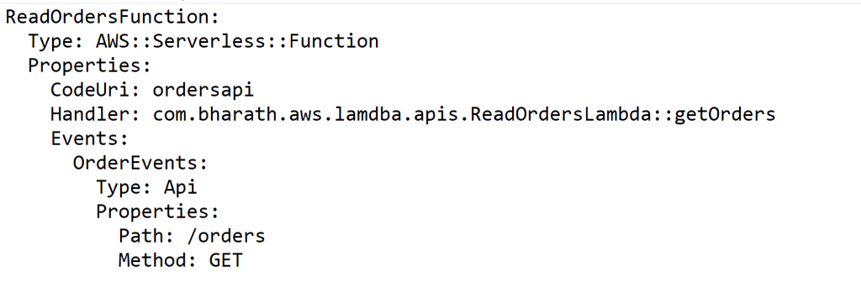

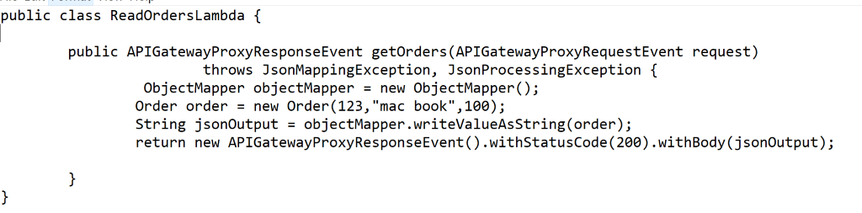

**Note :** we didn’t use dynamo db yet . We are hoisting a static api

**Test Read Orders**

**Sam build**

**Sam deploy**

Grab a previous url and hit it with GET method . It will return response

Once we deployed a new end point will be created in api gateway

Ordersapi/ orders---POST

     GET

Cloudformation will not only create entire API gateway but it will add endpoint also

**Test Locally**

Under the project run below command

**Sam local start-api :** that will launch a simulated URL on api

And give <http://127.0.0.1:3000/orders> hit in postman

This will not go api to gateway in cloud but simulated api in local

**Use Global Properties**

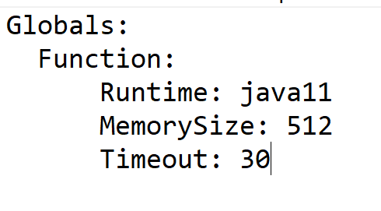

**Repetitive** property which will apply across the resource type

**Create table resource**

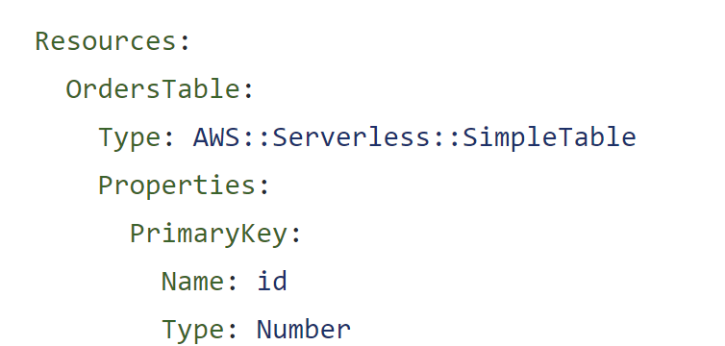

**It wi**ll create a table but how  does our lambda know about the table name

**!Ref** :--- whenever resource is created dynamically please give me that final name

Name of table :**OrdersTable**

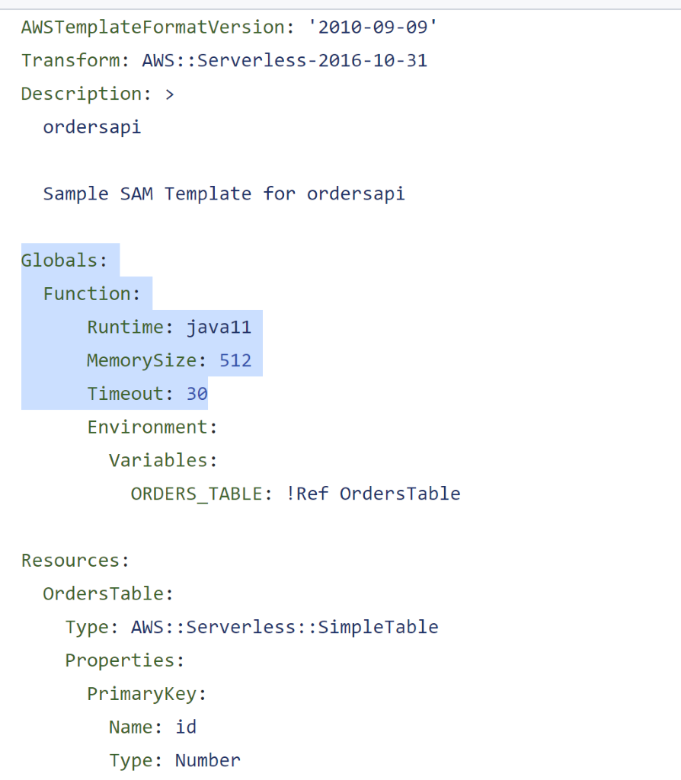

**In next** lecture we will reading the env variable and using that will store the data

**Create Item**

**Will connect** to dynamodb using class CreateOrderLambda and create order record in dynamo db table

Step 1 :

 Will add maven dependency in pom.xml

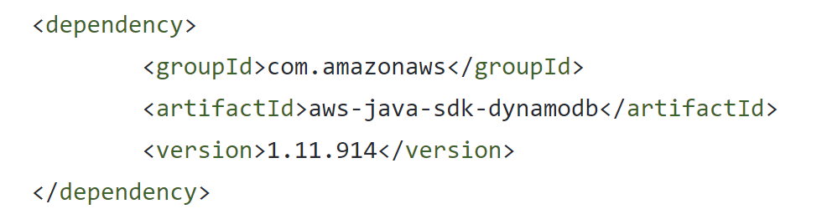

**AmazonDynamoDBClientBuilder.defaultClient()** :--- that know how to connect to d/b

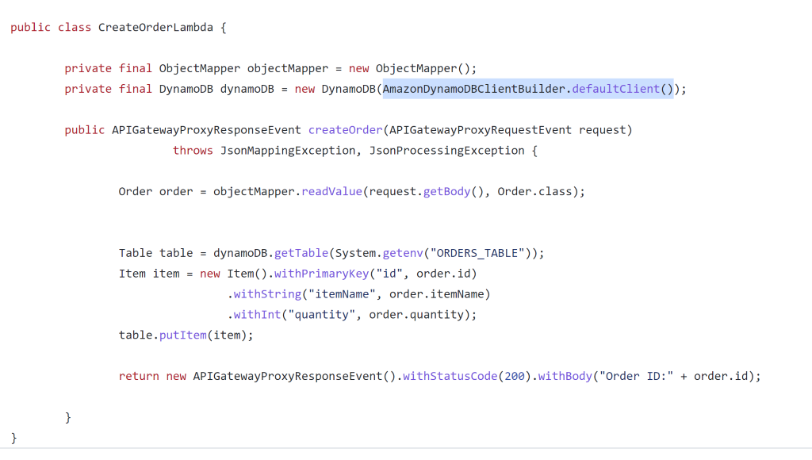

GetTable is defined in DynamoDb class that’s why we are using new DynamoDb

While in case of read we don’t need to use new DynamoDb

**Read Items**

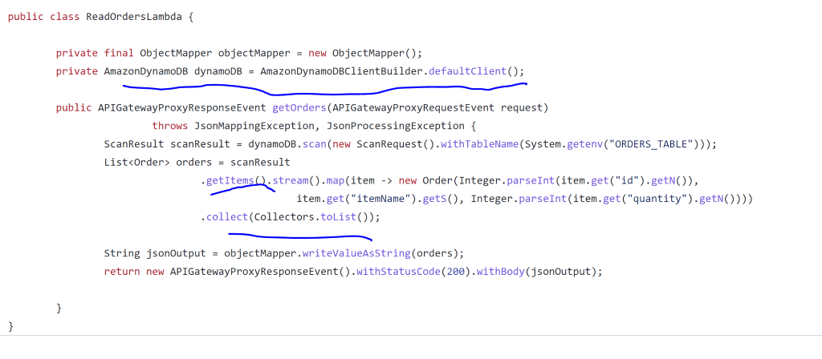

**Configure Security Policies**

**Note :**

We need to assign policies so that it can perform operation against dynamo db.

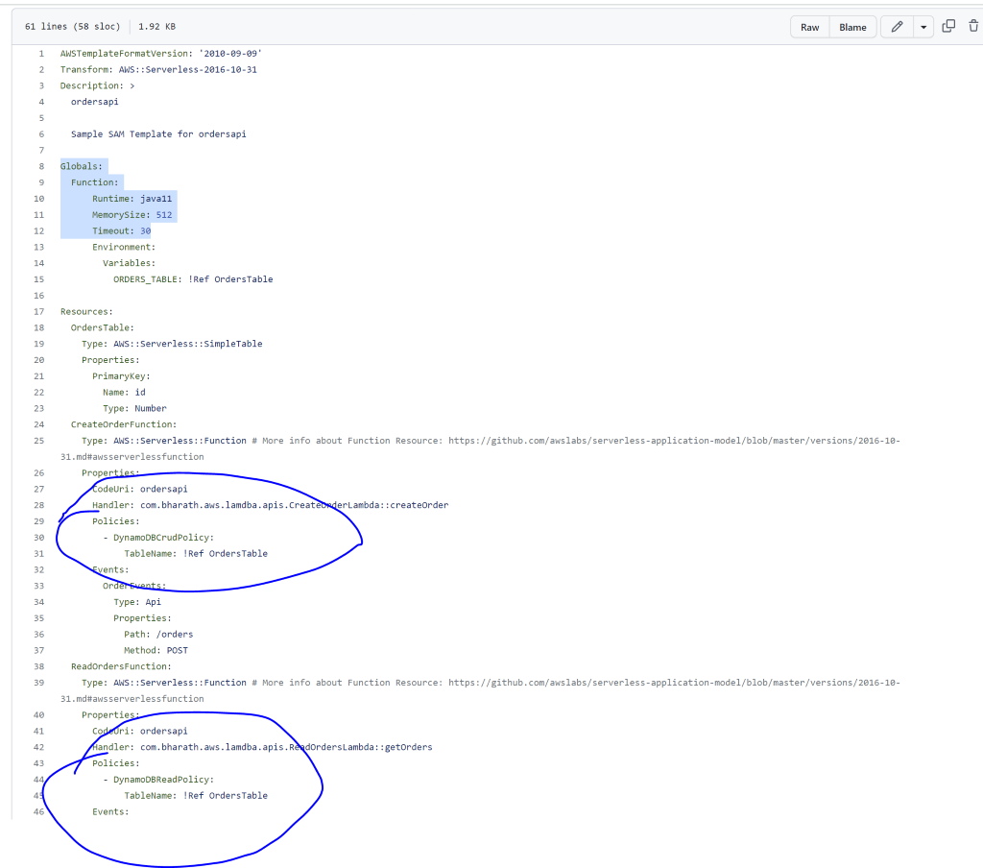

Policy will be bind to lambda function

**Deploy and Test**

**Sam build**

**Sam deploy**

 Go to api gateway and grab the url

**Output Resource Info**

**How** to show additional info when we do a sam deploy

!Sub : it will substitute the value when stack is created

We will get url in console after sam deploy

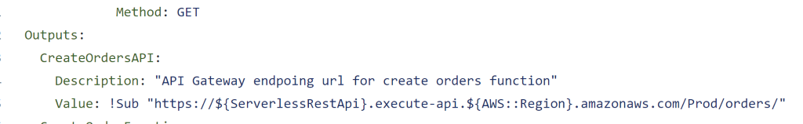

**Use GetAttr Intrinsic Function**

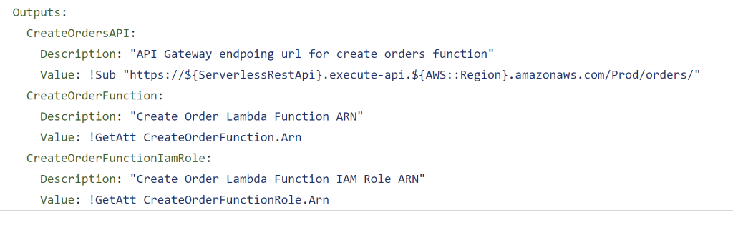

**Refactor:**

Want to use same instance then defined it globally

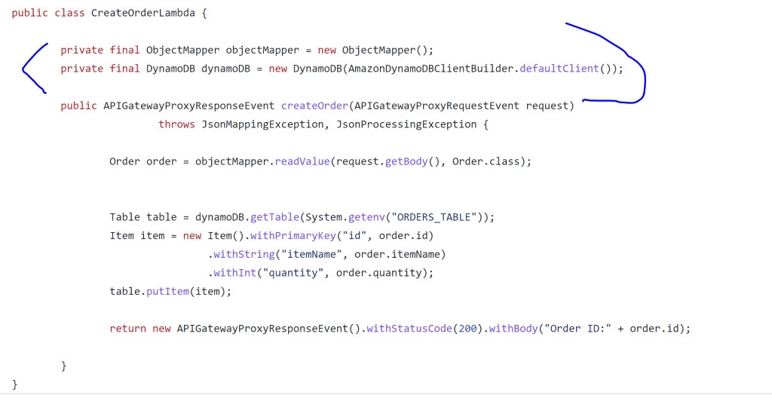

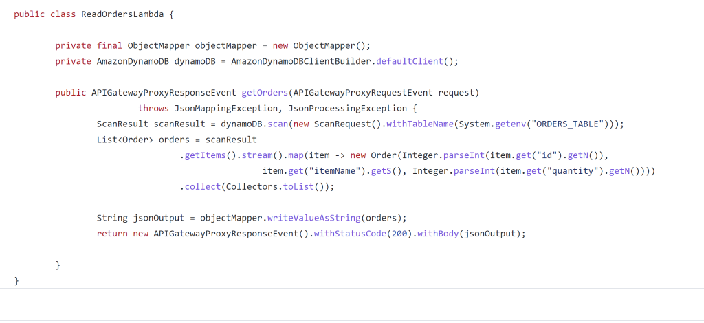

 Section 6 : Asynchronous usecase

Usecase :

When patient checkout and file is uploaded into s3 will configure our lambda in such a way that it will trigger lambda function and lambda function will read a file and it will create object per patient and all the content of json file will converted into java object

For one patient lambda function will create one message and it will put into SNS topic

Note

When file is uploaded into s3 it will trigger a lambda function

So first lambda will take one patient at a time convert it into message or deserialize it and put it into SNS topic

Sns will trigger second lambda which is asynchronous  and it will receive data and process it and renders it  as a report or into the  logs

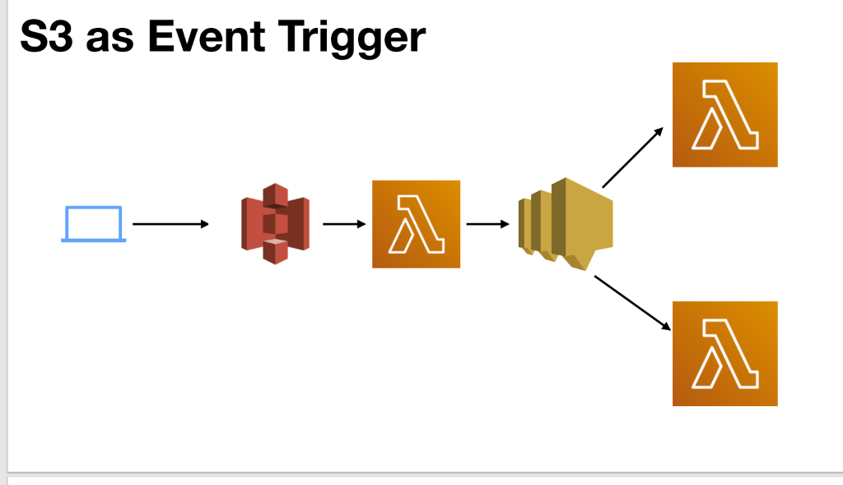

**S3 Quick Review**

S3 stands for **simple storage service** S3 is an object based storage system it uses the concept of bucket IT support versioning of file even if required so s3 can even trigger Lambda function. There is a event notification section of properties section for all s3 Which can do even trigger We are not doing configuration here we are doing everything using Sam

**API and SDKs**

when file is  uploaded into s3 it is our Lambda function responsibility to get the data from the event. Event will not have the data

**Create the project**

**Sam init**

**Name of project :**PatientCheckout

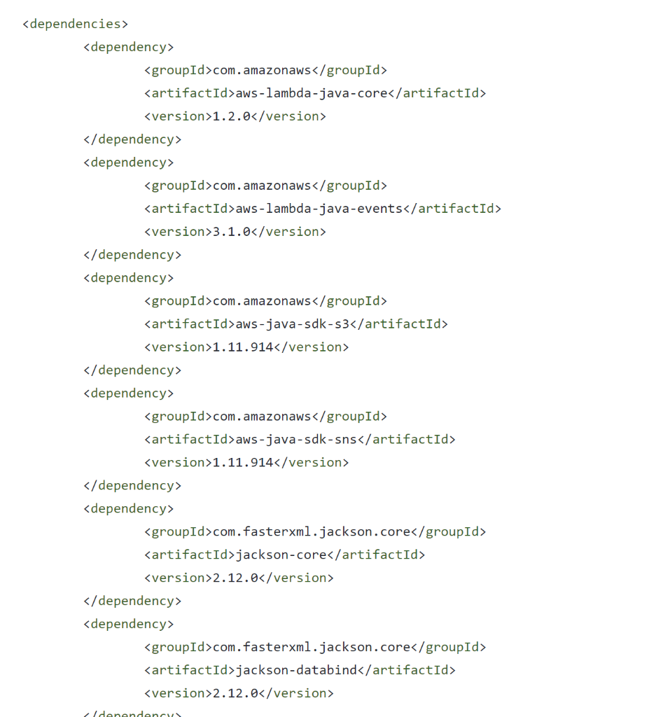

**Create model and Lambda classes**

**Create model**

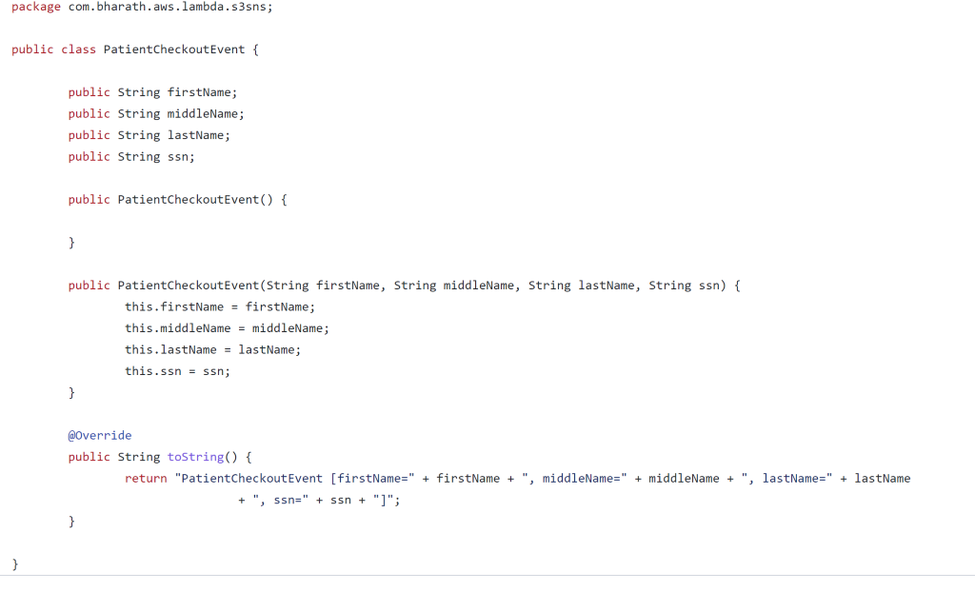

**Implement The PatientCheckoutLambda**

**PatientCheckoutLambda :** will handle the event from s3

**Bill ManagementLambda** : this will handle the event from sns

This Lambda function will  receive the  s3 notification when file is uploaded into S 3.

Using s3 api will read the file and then using object mapper will convert into list of java object

**Note :**

In s3 everything we uploaded is called object

AmazonS3 will give access to s3 service

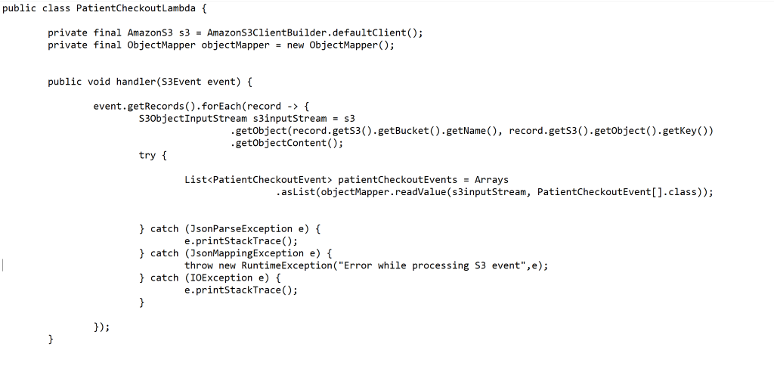

**Configure Lambda and resources**

Here will configure PatientCheckoutLambda  in**template.yaml**

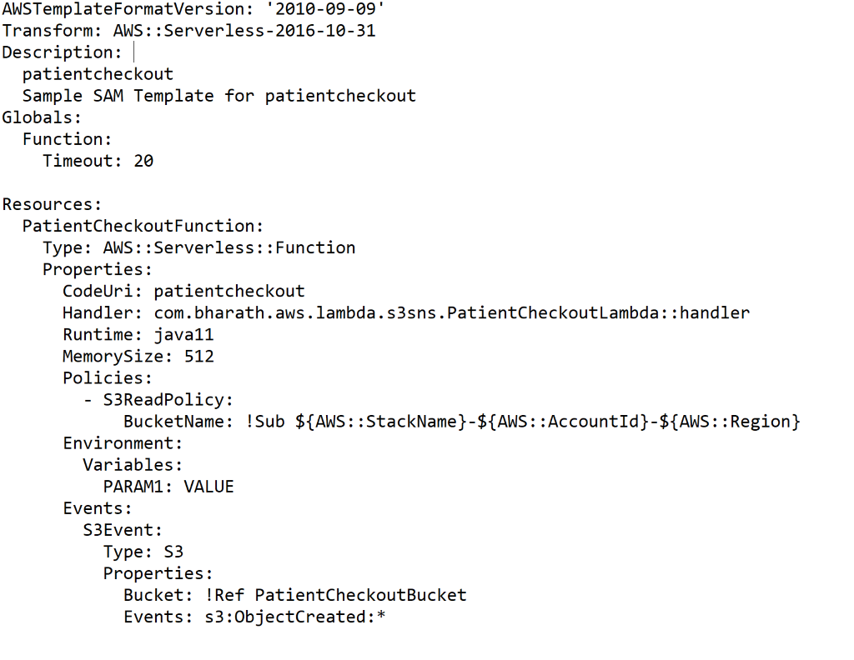

**Test**

**PatientData.json**

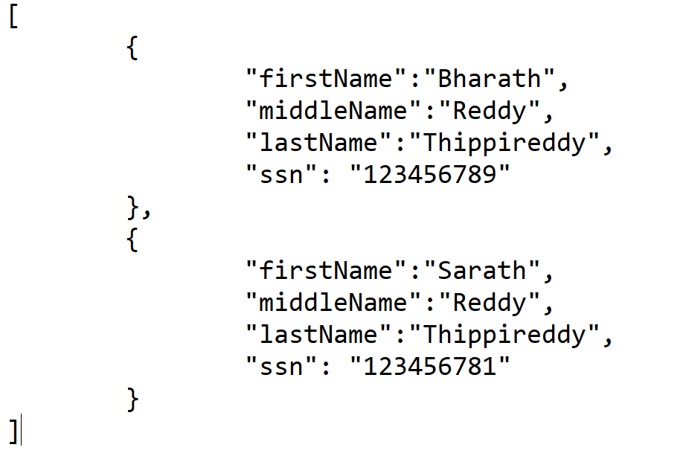

Lambda function will read from s3 bucket when file is uploaded

**Test**

Sam  build

Sam deploy – guided

StackName  : patientCheckout and rest is default

Once is it done check s3 it will created by stack name_ accountid _region

As file is uploaded it will trigger a lambda function.

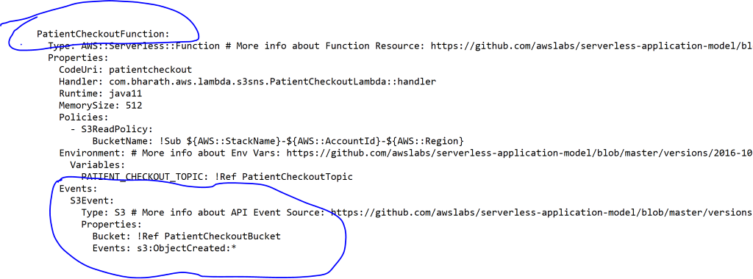

Go to lambda function , monitoring tab then view logs in cloudwatch

And it will process s3 data and print in log



**Configure SNS topics**

**The** first lambda function has successfully read json data from s3 bucket and converted it into json array

Now we will read this array and fire out message to SNS topic

**Note :**

Now first lambda function will need access to SNS topic  for this will define environment variable in template for SNS

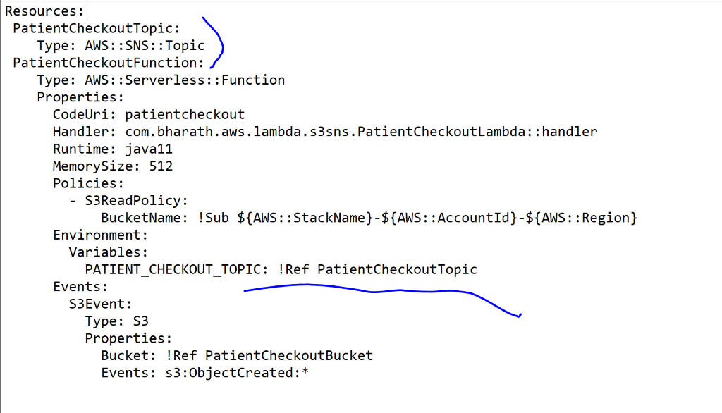

It will dynamically get the SNS topic name

**Publish Message**

**Requirement :**

Publish the event to SNS topic using lambda

For this we will loop through PatientCheckoutEvent and will fire a message to SNS topic for each event

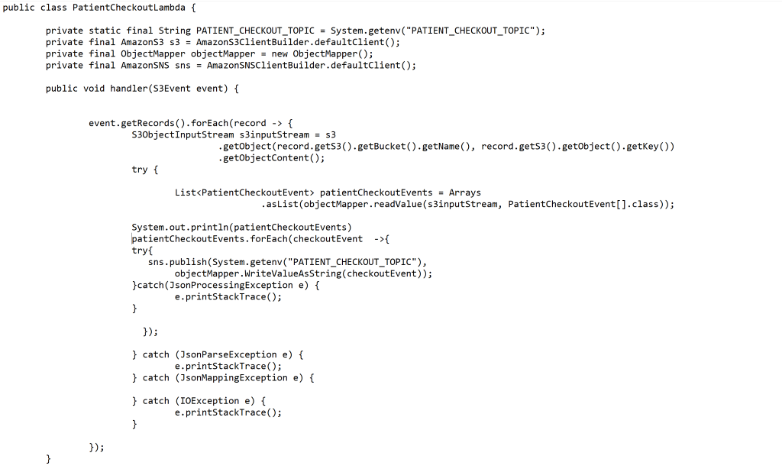

**Implement Bill Management Lambda ( other** lambda function will read from SNS topic)

**NOTE :  sns** will trigger this lambda function

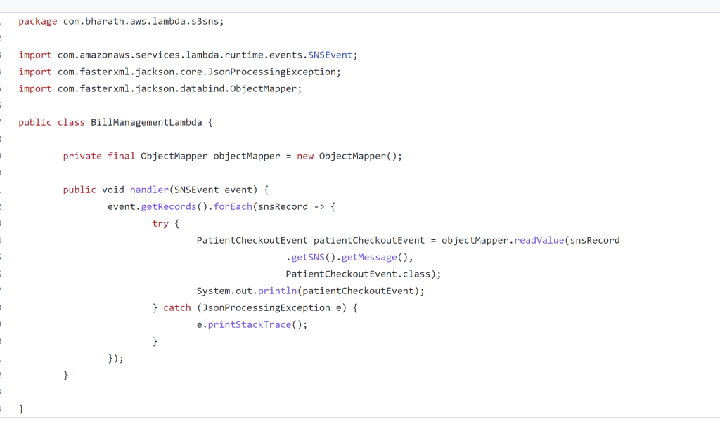

**Configure BillMangementLambda and resources**

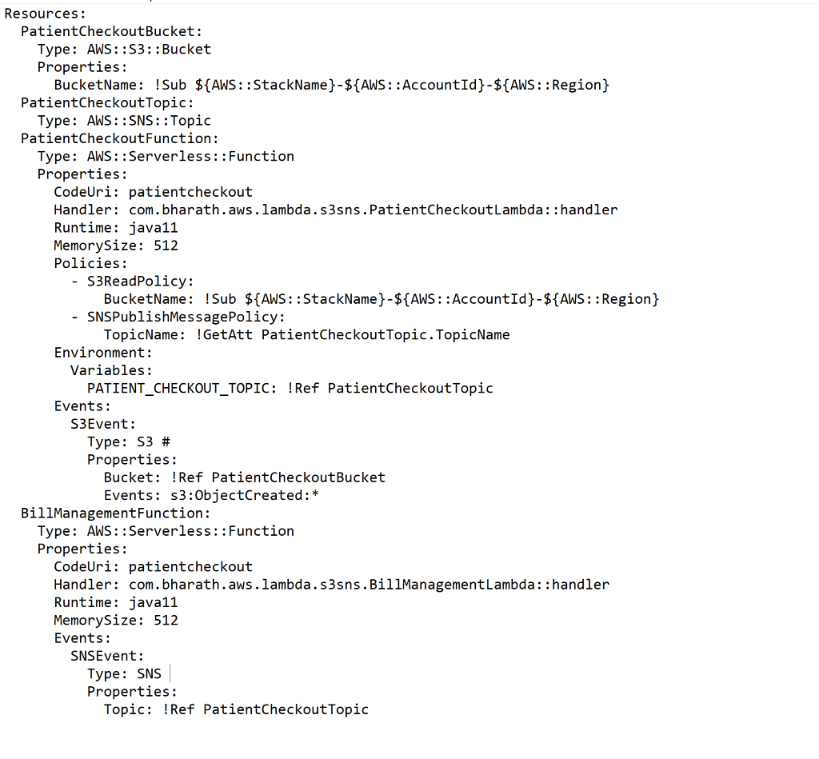

**Test complete workflow**

**Sam build**

**Sam deploy**

**Note :**we can check everything in cloud formation , will have two lambda function

**Refactoring**

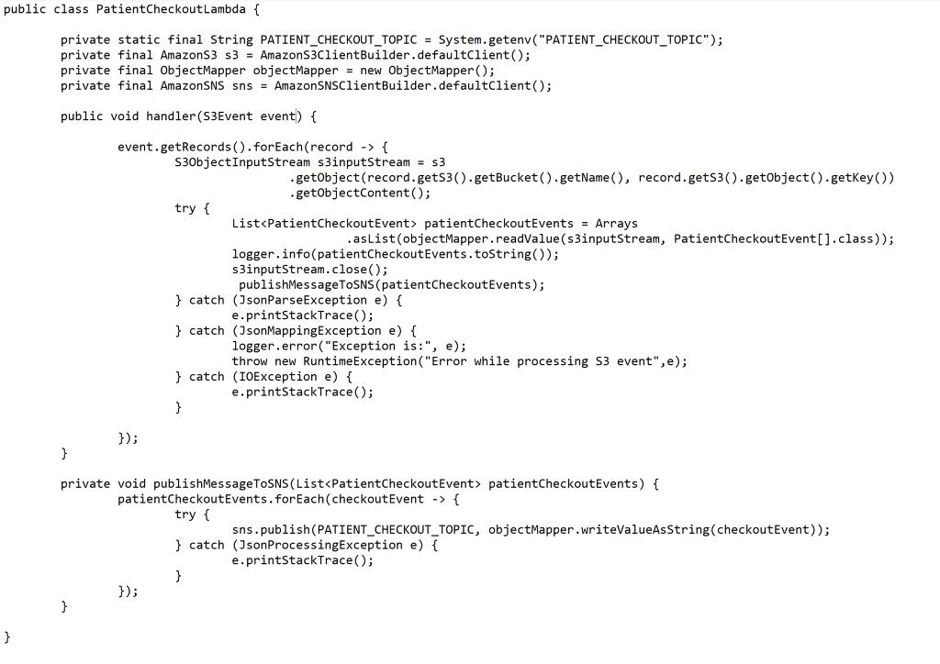

Section 7: Logging and error handling

**Using sysout statements**

**If we** use e.printStackTrace and if exception come it will not show in one line but in multiple lines in aws cloudwatch so we should use logger.

**Using lambda context logger**

**Requirement :** how to use aws context logger instead if sysout statement

Use context from context we can get logger

**Using log 4j**

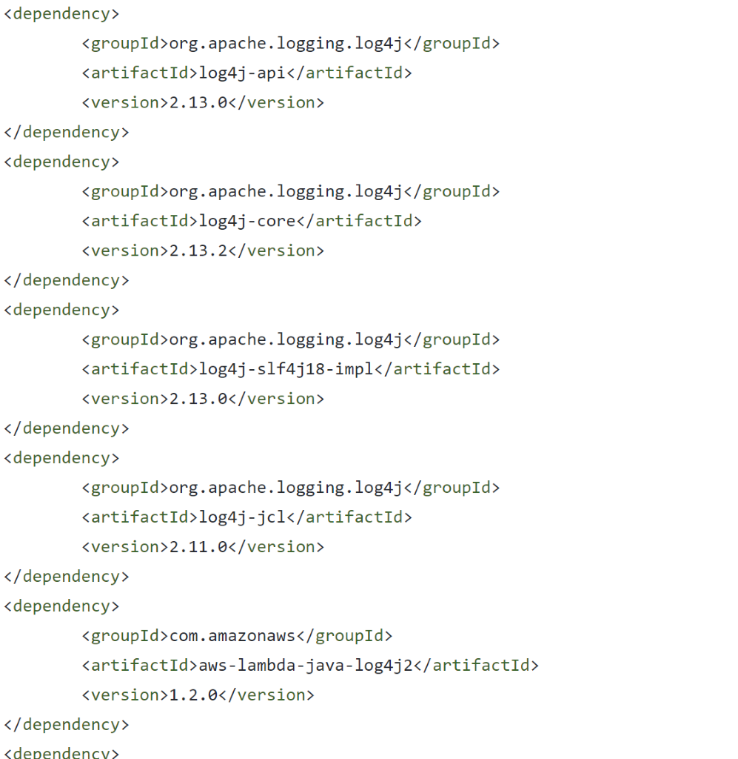

**We can** use log 4j api instead of context logger

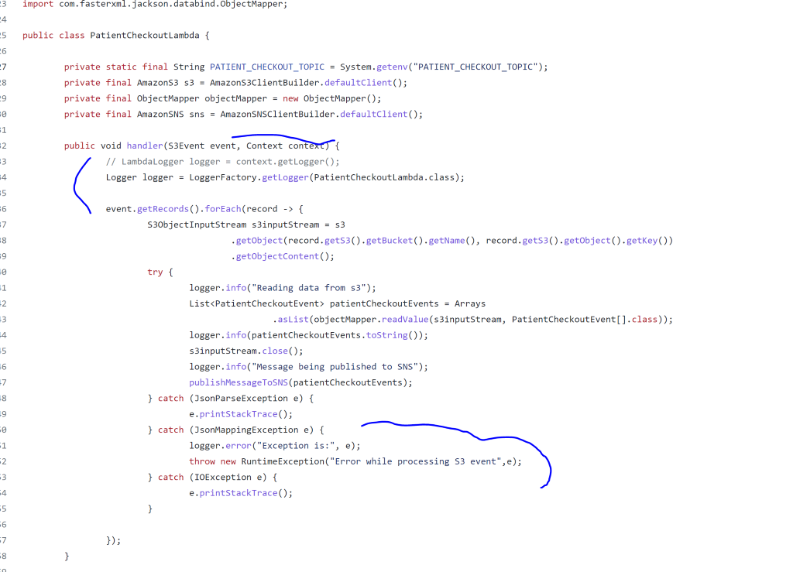

**We need** to copy log4j2.xml under resources folder. Lambda function support log4j

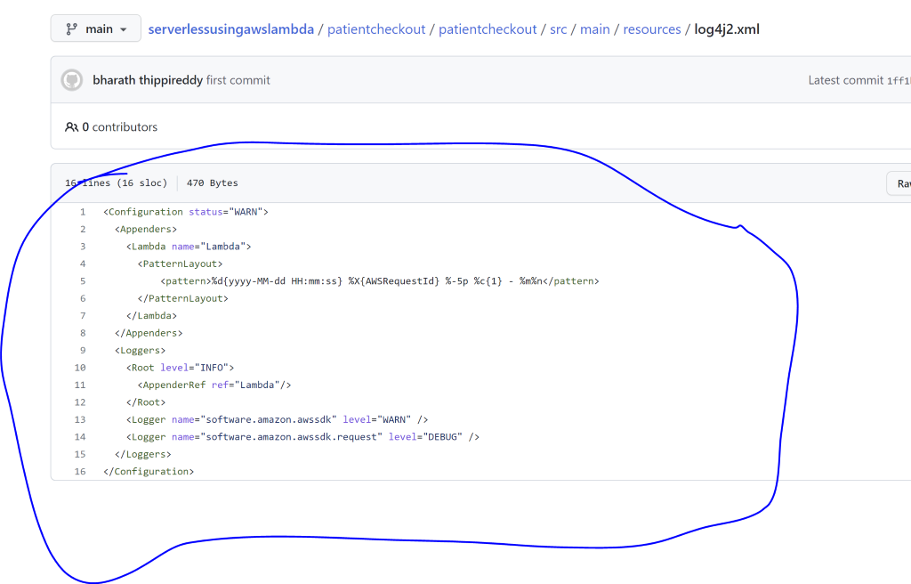

**Imp**: now request id will attached to each log which is very helpful

**Error handling**

**How** to handle error within our lambda

In case of async where upstream is not expecting response we can use retry.

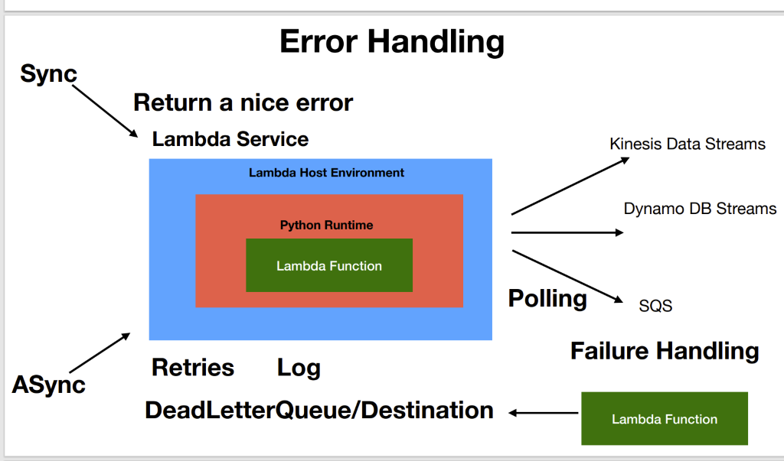

**If after retries** if it is still fails( may be database is down) then will log the exception

And what if database is up and we want to reprocess the event but event is not there

That is where **deadLetterQueue**come in picture

**DeadLetterQueue**:  they are use to store the event after the retries is happen before the lambda is shut down the event will be send to DLQ and appropriate action can be taken on event once the error is resolved

Or we can configure lambda on DLQ which will take better action depending on business requirement

That is how we handle exception in case of asynchronous call

**By default lambda function have retries 2**

**Create error handler lambda**

**ErrorHandler:** this is the lambda function that will be trigger by DLQ  event on SNS

Note :

We need to throw exception in DLQ so that  DLQ come to know something is thrown

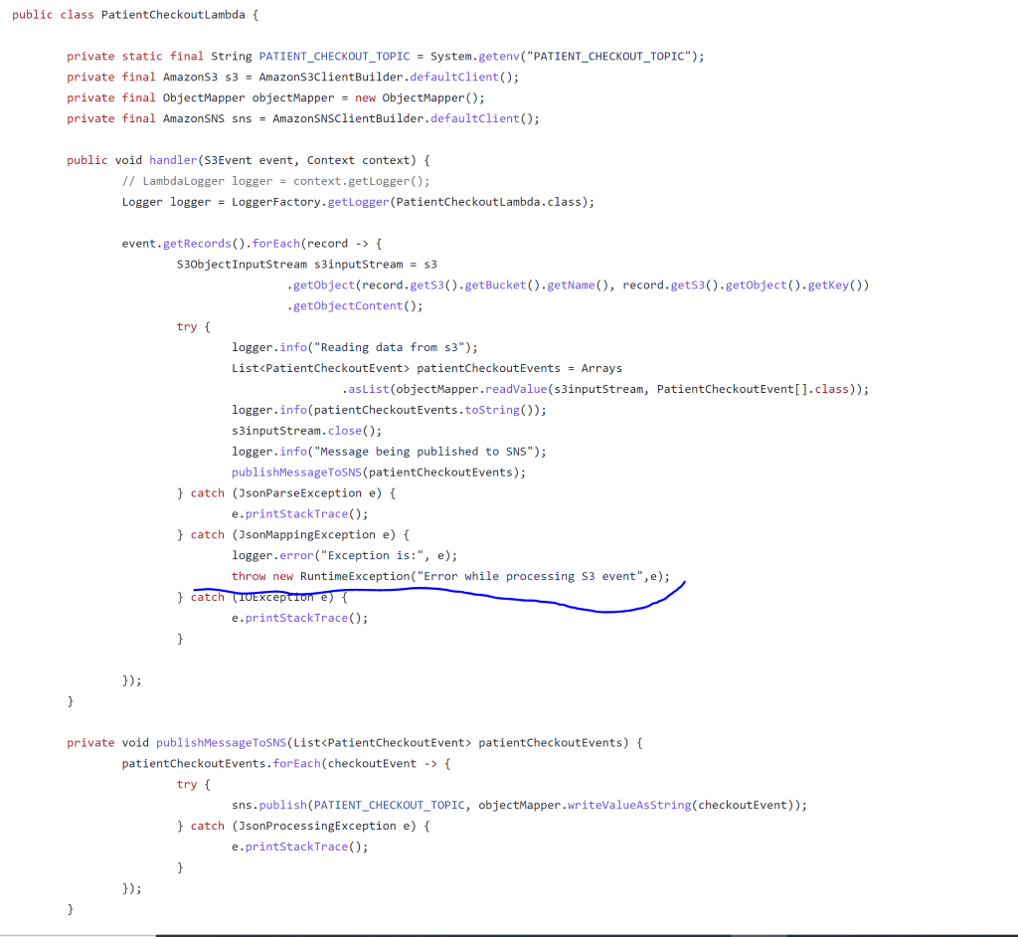

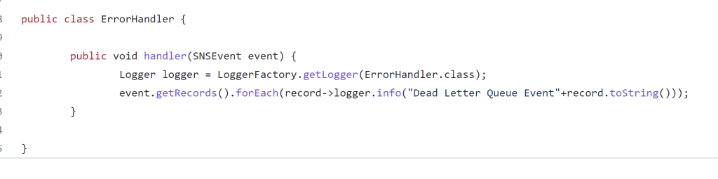

**Configure DLQ  and errorHandler**

Will configure DLQ for patientCheckoutFunction and also errorHandler in template.yaml

After configuring DLQ in patientCheckoutFunction  automatically patientCheckoutFunction  will

Forward event to DLQ on SNS which will trigger errorHandlerLambda function

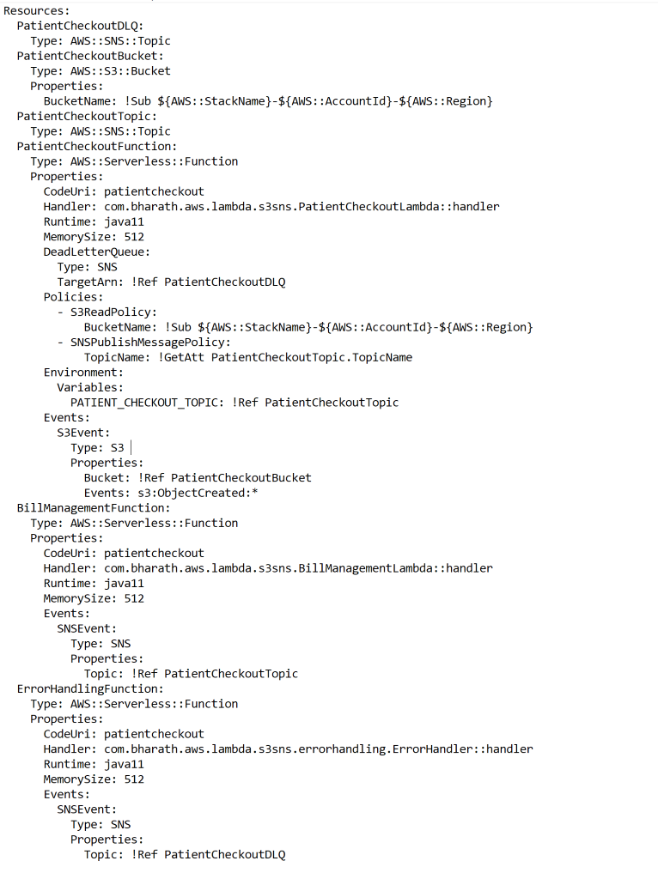

**Deploy and Test**

Sam build :

New template.yaml will be pick up

S3—file upload trigger- patientCheckoutLambda function exception occur---- trigger DLQ on SNS---- trigger errorHandler Lambda function

Note :

Even if exception occue in lambda function first it will retry after a min  then again will retry after 2 min . After 2 retry finish it will try for DLQ.

We can configure **MaximumRetryAttempts**: 0 in patientCheckoutFunction

**Whatever the event received by PatientCheckoutFunction that will be pass to DLQ**

Section 8: More Concepts

**Scaling**

**Will test this :** will put thread.sleep(5000) in patientCheckoutFunction

Note : each instance of lambda function will have own log stream

**How to test**

Will upload two file in s3 and will see if two stream triggered that means there are two instance of lambda function created

Lambda service has created two instances for our lambda because we have added a delay

**Cold start**

When lambda is created very first time the lambda service will setup entire environment that is required for lambda to work. It will load lambda class to memory. The entire process is called cold start

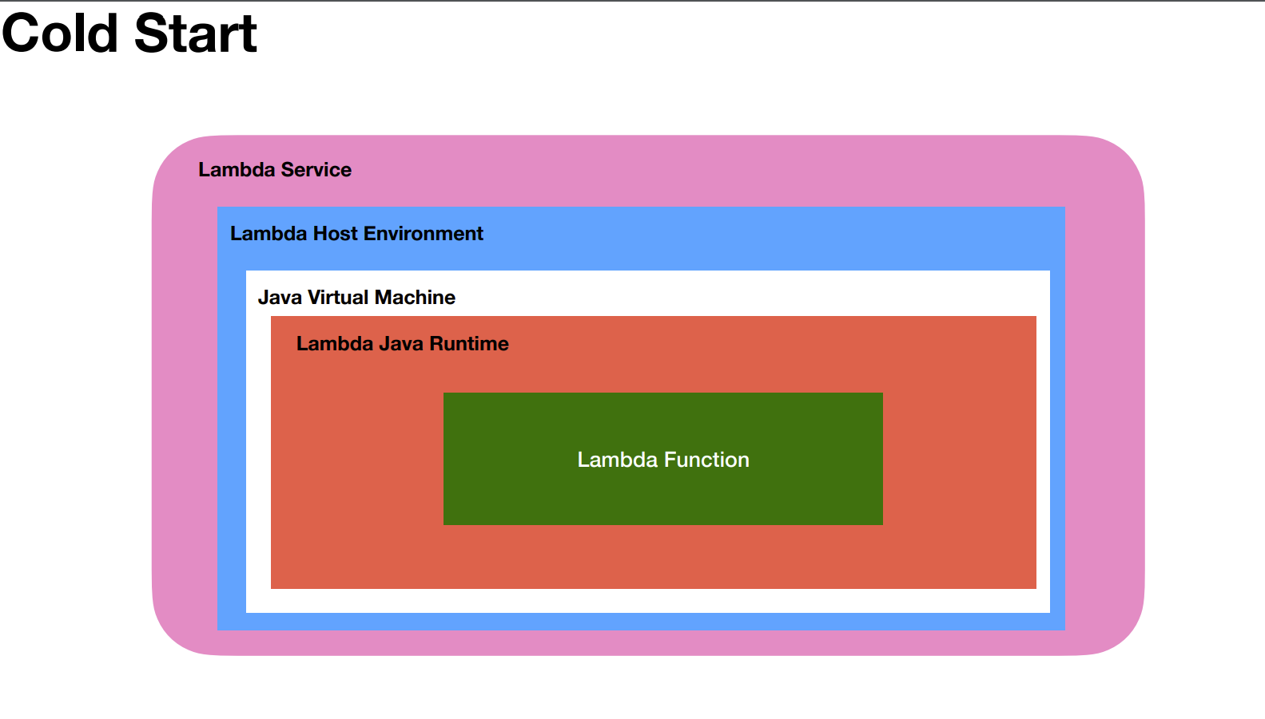

**A cold** start when lambda is triggerd not when it is deployed and the cold start does not happen on every invocation of lambda. Lambda service freeze the lambda instance so that it can be reuse for few other event that might occur immediately

**When the cold start happen**

**The cold start** happens when the lambda is triggered very first time

Lambda is triggered very first time when it is deployed or first request comes in

Updated the lambda code and redeploy it and request comes in

**Cold start** : same instance will be reuse across lambda invocation

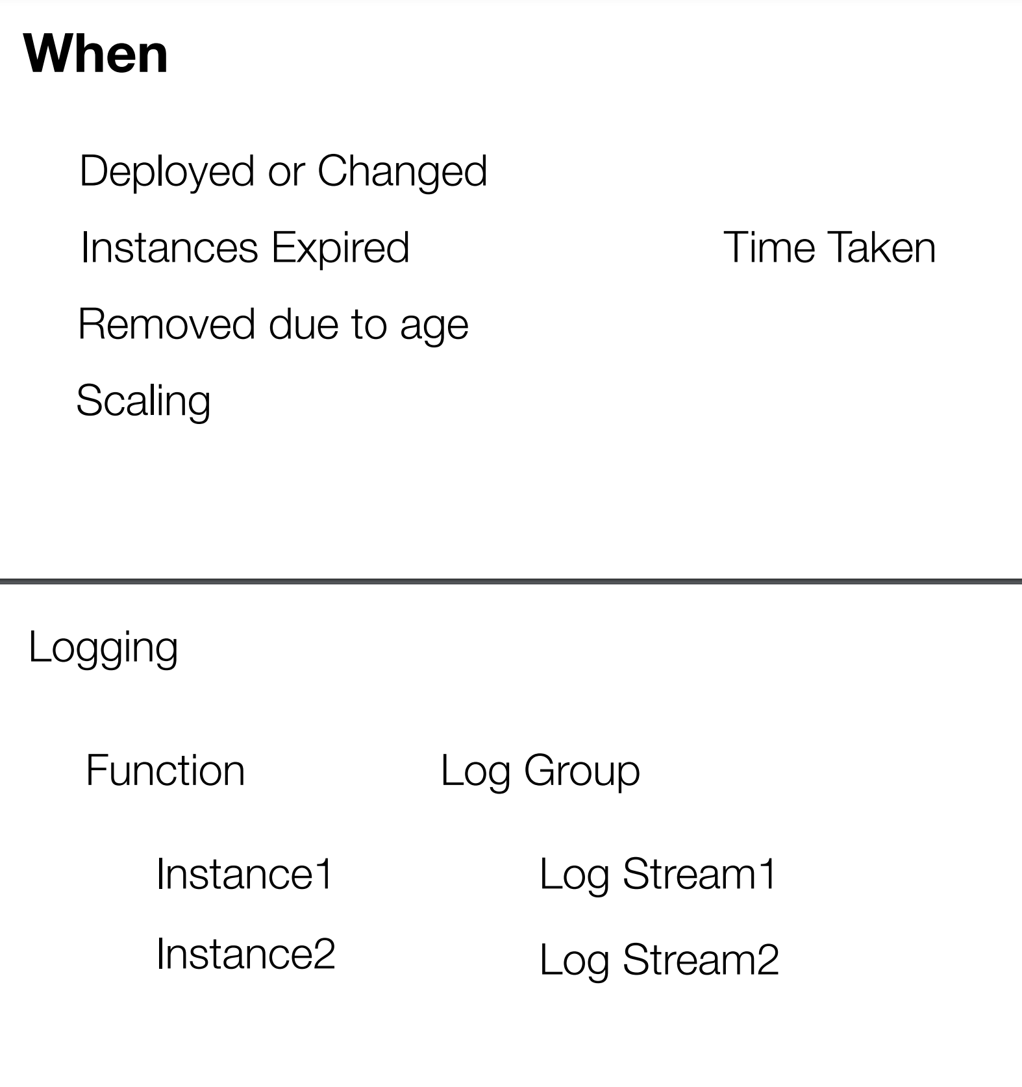

**Cold start demo**

When multiple files will be upload in s3 the same instance will be use for lambda function. How we will know that through log streams.

Same log stream will use in cloudwatch to capture logs due to cold start.

**Multithreading**

Thread will finish the job before the lambda function returns

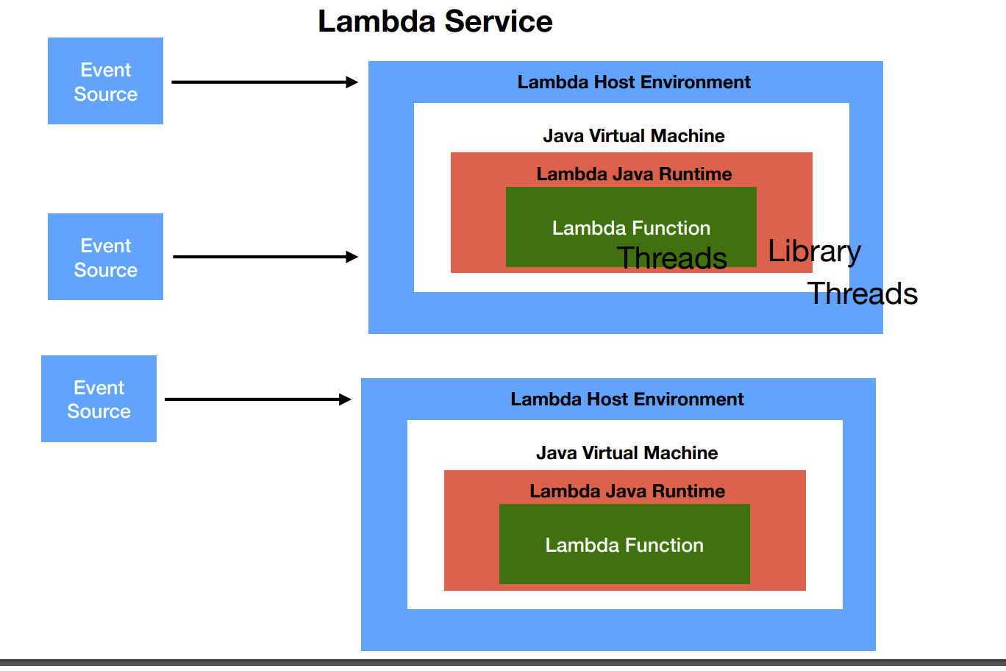

                   Section 9: SQS as event source

 When we trigger lambda function using api gateway then it is synchronous call

To make it asyn will insert SQS queue into this workflow

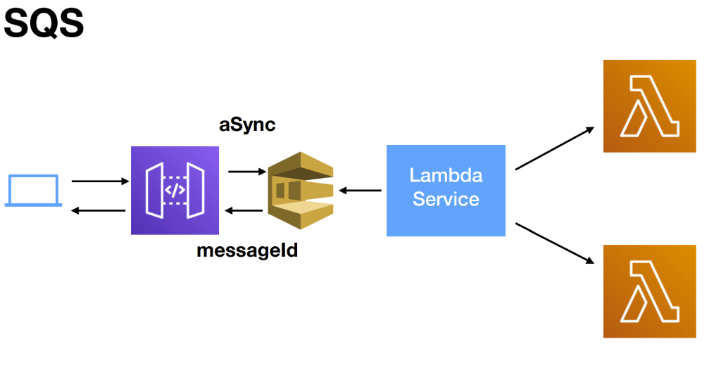

**Why use SNS and SQS together?**

Using Amazon SNS and Amazon SQS together, **messages can be delivered to applications that require immediate notification of an event, and also persisted in an Amazon SQS queue for other applications to process at a later time**.

The SQS queue will become a event source for lambda function.

That is when client send a request to api gateway and api gateway take a request

and put a message on sqs queue. The sqs will return a unique message id .

That message id is given back to client and he can use it  To track what happen to request. The api gateway and sqs need not wait for lambda function to trigger and finish the execution.

**Suppose for order service**:- api gateway will put order as a message to sqs queue and

it is responsibility of lambda function to keep polling sqs queue and whenever

there is a message it take message as a event and pass it to lambda function

That is the main difference whenever we uses sns it will trigger lambda function but when we use sqs it is the responsibility of lambda function to keep polling sqs queue

Whenever there is message in sqs take a message convert it into event and process it.

Lambda service read the **messages in batches. By** default it read 5 batches at a time

And number of messages in each batches is can configured through configuration.

When lambda service give batch to lambda function then it will be hidden from other lambda.

This can be controlled using visibility timeout setting

But if one message in batch**failed**the entire batch will be process again so we need to take care  of duplicate processing logic. If the same message come again we should handle them in lambda function.

Once the message is processed from the batch it deletes all the message from the queue

And if the message failed so many time we can configure DLQ

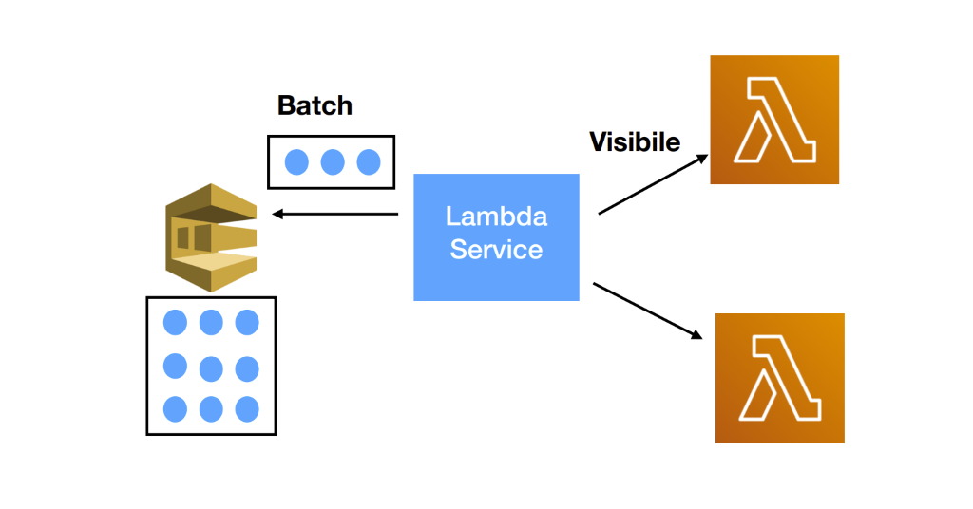

**Usecase**

In hospital we have lambda function (claimManagementLambda) that will handle claim like insurance will receive a SQS event that will have entire batch info

**Create Lambda function**

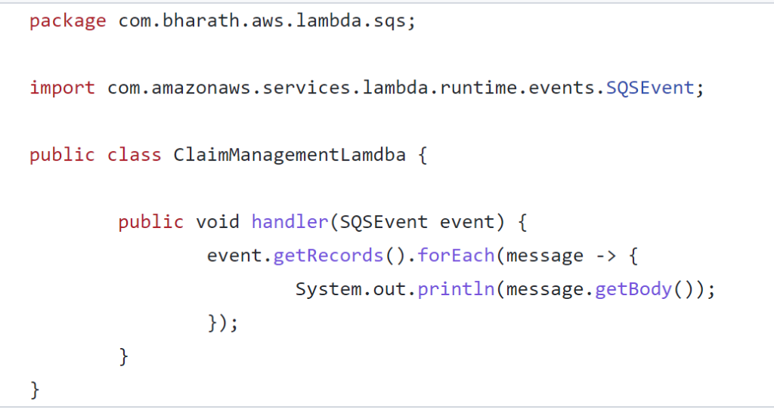

**Configure lambda and resources**

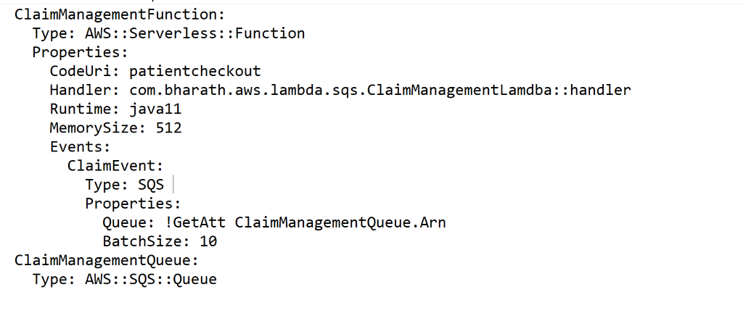

**Deploy and Test**

Sam build

Sam deploy

Send message from sqs in aws and then it will trigger a lambda function

Then check logs in cloudwatch